**CRIME AND PATROL MANAGEMENT SYSTEM**

**PROBLEM STATEMENT:**

We have all dreamt of a world where all our friends and relatives feel safe and protected from all the delinquents. All the criminals and rule breakers should be held accountable for the crime committed by them. And all the people should be able to bravely voice out the wrong doings of people to safeguard their loved ones. Our website tries to make this dream come true.

**INTRODUCTION:**

Our world is a place that is filled with infinite number of threats. Right from the moment we step outside our home, we become susceptible to all kinds of dangers. The website that we designed tries to help the people in need by giving them a button to click whenever they feel that they or any one is in danger. The above feature is for the users. From the police’s view, our website allows them to collect important clues using the information obtained from the crime scene and from the information that is stored in our database about the user who is involved in the crime. In our website the doctors are allowed to access the medical details of the users and other details like the emergency contact of their patient. All of these views will not prevent all the bad happenings in our society but will at least reduce the number of bad happenings and help us safeguard our loved ones.

**MOTIVATION:**

In our daily life, we have always been the bystanders whether it comes to watching a crime that is taking place or staring at a person suffering from an accident. For once in our life, we wanted people to take some action instead of just being a person who witnesses from a corner recording videos or just staring at the events that unfold. We have always either been a spectator or a victim of bribery. We wanted people who follow rules to go about their daily lives without thinking about the extra money they will have to pay in order to satisfy the needs of the police officers. All these scenarios motivated us to take some action.

**MODULES:**

There are three modules in this website:

* Common people
* Doctors
* Police

**I. Common people:**

* + - * + Sign-up/log-in
        + View/edit their profiles except the crime and penalty options.
        + Make a call if a crime takes place
        + Make a call for requesting ambulance service
        + Pay penalties
        + Make a call during emergencies

**II.Police:**

* + - * + Sign-up/log-in
        + View/edit their profiles
        + Make a call if a crime takes place
        + Make a call for requesting ambulance services
        + Make a call during emergencies
        + Pay penalties
        + View/edit the user’s profile (only information related to crime and penalty)
        + Access information related to the user and their vehicle
        + Store details on any crime related calls

**III.Doctor:**

* + - * + Sign-up/log-in
        + View/edit their profiles
        + Make a call if a crime takes place
        + Make a call for requesting ambulance services
        + Make a call during emergencies
        + Pay penalties
        + View/edit the user’s profile (only information related to the health of the user)
        + Access information related to the user, their vehicle and health
        + Store details regarding the patient being treated.
        + Retrieve the information of all the patients treated

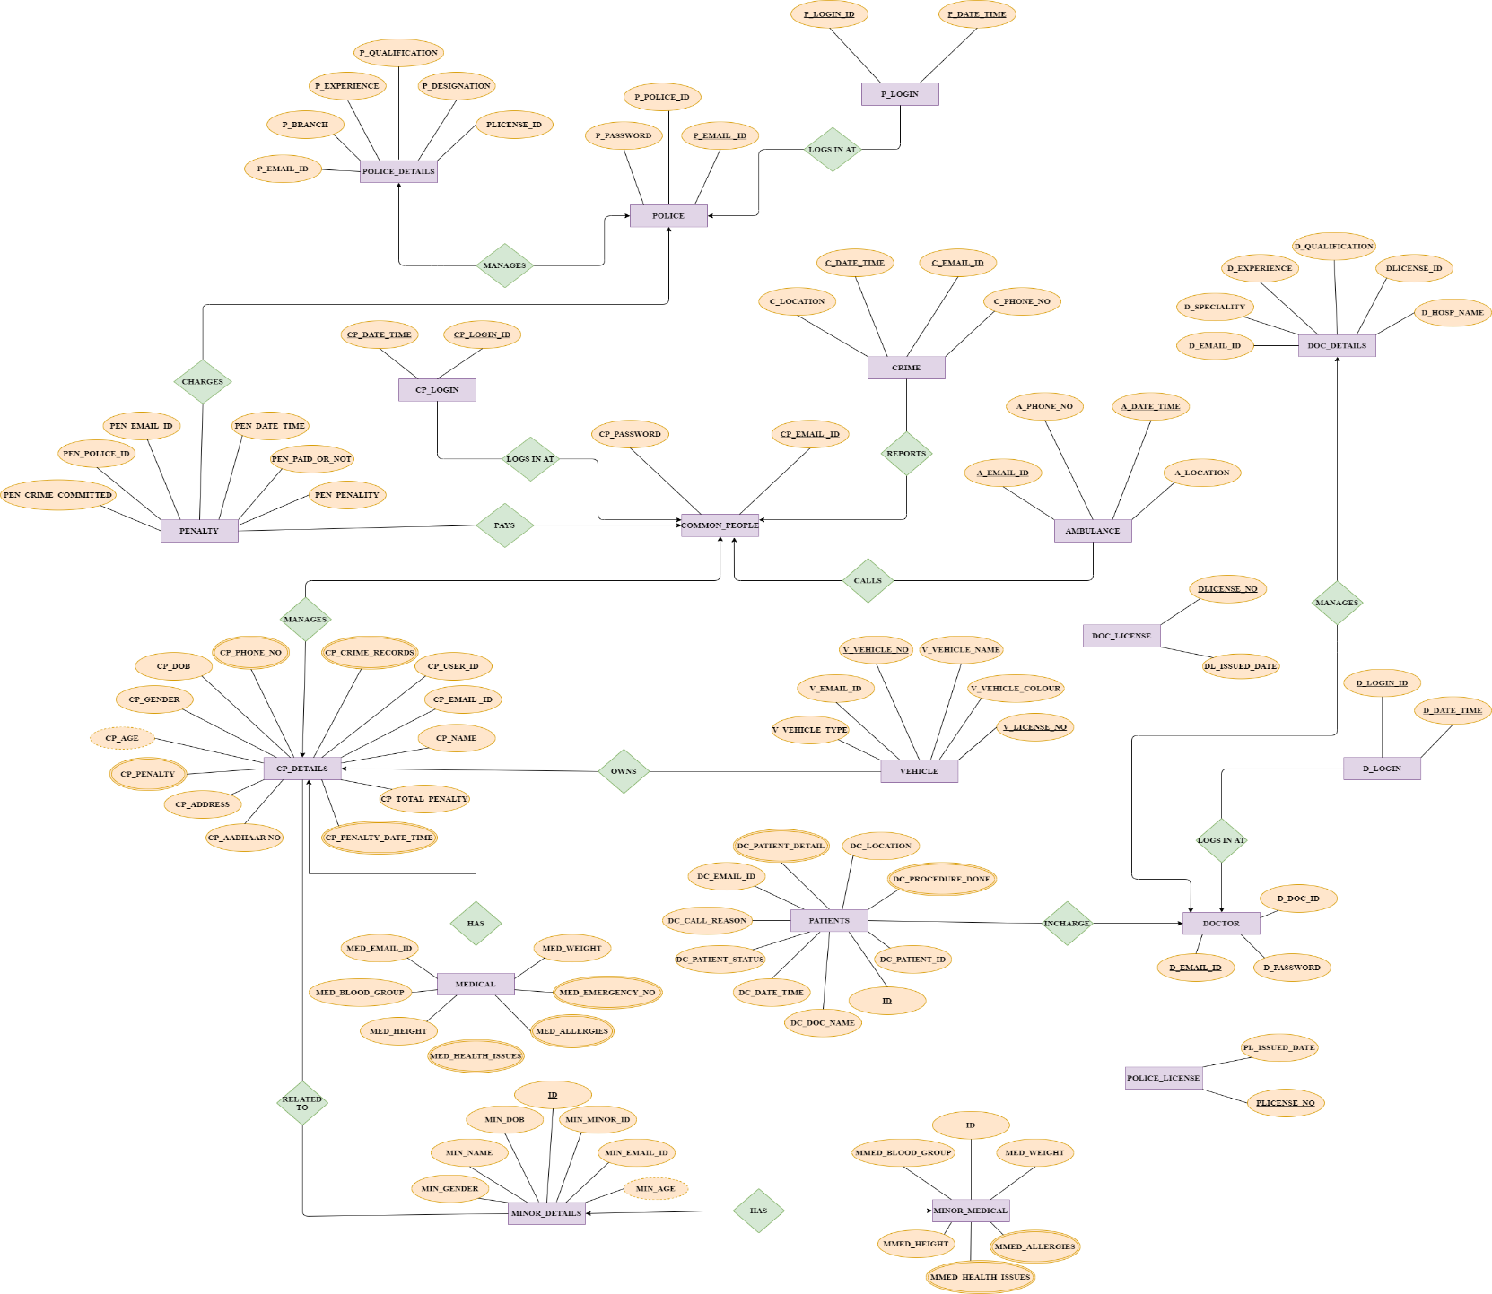ER diagram:

BEFORE NORMALIZATION:

**HIGHLIGHT: MULTIVALUED**

**HIGHLIGHT: PRIMARY KEY**

(CP_EMAIL_ID, CP_PASSWORD,

CP_LOGIN_ID, CP_DATE_TIME,

CP_AADHAAR_NO, CP_USER_ID, CP_NAME, CP_GENDER, CP_ADDRESS, CP_PHONE_NO, CP_DOB, CP_AGE, CP_CRIME_RECORDS, CP_PENALTY, CP_PENALTY_DATE_TIME, CP_TOTAL_PENALTY,

C_EMAIL_ID, C_PHONE_NO, C_LOCATION, C_DATE_TIME,

PEN_CP_EMAIL_ID, PEN_EMAIL_ID, PEN_CRIME_COMMITTED, PEN_DATE_TIME, PEN_PENALITY, PEN_PAID_OR_NOT,

A_EMAIL_ID, A_PHONE_NO, A_DATE_TIME, A_LOCATION,

V_EMAIL_ID, V_VEHICLE_NO, V_VEHICLE_TYPE, V_VEHICLE_NAME, V_VEHICLE_COLOUR, V_LICENSE_NO

MED_EMAIL_ID, MED_HEIGHT, MED_WEIGHT, MED_BLOOD_GROUP, MED_HEALTH_ISSUES, MED_ALLERGIES, MED_EMERGENCY_NO,

ID, MIN_MINOR_ID, MIN_EMAIL_ID, MIN_NAME, MIN_GENDER, MIN_DOB, MIN_AGE,

ID, MMED_HEIGHT, MMED_WEIGHT, MMED_BLOOD_GROUP, MMED_HEALTH_ISSUES, MMED_ALLERGIES

P_EMAIL_ID, P_POLICE_ID, P_PASSWORD,

P_LOGIN_ID, P_DATE_TIME,

P_EMAIL_ID, P_QUALIFICATION, P_DESIGNATION, PLICENSE_ID, P_EXPERIENCE, P_BRANCH,

PL_PLICENSE_NO, PL_ISSUED_DATE,

D_EMAIL_ID, D_DOC_ID, PASSWORD,

D_LOGIN_ID, D_DATE_TIME,

D_EMAIL_ID, D_HOSP_NAME, DLICENSE_ID, D_QUALIFICATION, D_EXPERIENCE, D_SPECIALITY,

DL_LICENSE_ID, DL_ISSUED_DATE,

ID, DC_EMAIL_ID, DC_PATIENT_ID, DC_PATIENT_DETAIL, DC_LOCATION, DC_PROCEDURE_DONE, DC_DOC_NAME, DC_DATE_TIME, DC_PATIENT_STATUS, DC_CALL_REASON, DC_PATIENT_ID)

**FIRST NORMAL FORM:**

**HIGHLIGHT: PRIMARY KEY**

(CP_EMAIL_ID, CP_PASSWORD,

CP_LOGIN_ID, CP_DATE_TIME,

CP_USER_ID, CP_AADHAAR_NO, CP_NAME, CP_GENDER, CP_ADDRESS, CP_DOB, CP_AGE, CP_TOTAL_PENALTY,

C_EMAIL_ID, C_PHONE_NO, C_LOCATION, C_DATE_TIME,

PEN_CP_EMAIL_ID, PEN_EMAIL_ID, PEN_CRIME_COMMITTED, PEN_DATE_TIME, PEN_PENALITY, PEN_PAID_OR_NOT,

A_EMAIL_ID, A_PHONE_NO, A_DATE_TIME, A_LOCATION,

V_EMAIL_ID, V_VEHICLE_NO, V_VEHICLE_TYPE, V_VEHICLE_NAME, V_VEHICLE_COLOUR, V_LICENSE_NO,

MED_EMAIL_ID, MED_HEIGHT, MED_WEIGHT, MED_BLOOD_GROUP,

ID, MIN_MINOR_ID, MIN_EMAIL_ID, MIN_PHOTO, MIN_NAME, MIN_GENDER, MIN_DOB, MIN_AGE,

ID, MMED_HEIGHT, MMED_WEIGHT, MMED_BLOOD_GROUP,

P_POLICE_ID, P_EMAIL_ID, P_PASSWORD,

P_LOGIN_ID, P_DATE_TIME,

P_QUALIFICATION, P_DESIGNATION, PLICENSE_ID, P_EXPERIENCE, P_BRANCH,

PL_PLICENSE_NO, PL_ISSUED_DATE,

D_DOC_ID, D_EMAIL_ID, PASSWORD,

D_LOGIN_ID, D_DATE_TIME,

D_EMAIL_ID, D_HOSP_NAME, DLICENSE_ID, D_QUALIFICATION, D_EXPERIENCE, D_SPECIALITY,

DL_LICENSE_ID, DL_ISSUED_DATE,

ID, DC_EMAIL_ID, DC_PATIENT_ID, DC_LOCATION, DC_DOC_NAME, DC_PATIENT_STATUS, DC_CALL_REASON)

* (CP_EMAIL_ID, CP_PHONE_NO)
* (CP_EMAIL_ID, CP_CRIME_RECORDS, CP_PENALTY, CP_PENALTY_DATE_TIME)
* (MED_EMAIL_ID, MED_HEALTH_ISSUES)
* (MED_EMAIL_ID, MED_ALLERGIES)
* (MED_EMAIL_ID, MED_EMERGENCY_NO)
* (MMED_MINOR_ID, MMED_HEALTH_ISSUES)
* (MMED_MINOR_ID, MMED_ALLERGIES)
* (P_EMAIL_ID, P_PHONE_NUMBER)
* (P_EMAIL_ID, P_CRIME_RECORDS, P_PENALITY, P_PENALITY_DATE_TIME)
* (D_EMAIL_ID, D_PHONE_NO)
* (D_EMAIL_ID, D_PENALITY, D_PENALITY_DATE_TIME, D_CRIME_RECORD)
* (DC_PATIENT_ID, DC_PATIENT_DETAIL)
* (DC_PATIENT_ID, DC_ PROCEDURE_DONE)

**SECOND NORMAL FORM:**

* (CP_LOGIN_ID, CP_DATE_TIME)
* (CP_USER_ID, CP_EMAIL_ID, CP_PASSWORD, CP_AADHAAR_NO, CP_PHOTO, CP_NAME, CP_GENDER, CP_ADDRESS, CP_DOB, CP_AGE, CP_TOTAL_PENALTY, MED_HEIGHT, MED_WEIGHT, MED_BLOOD_GROUP)
* (C_EMAIL_ID, C_PHONE_NO, C_LOCATION, C_DATE_TIME)
* (PEN_CP_EMAIL_ID, PEN_EMAIL_ID, PEN_DATE_TIME, PEN_PAID_OR_NOT)
* (PEN_CRIME_COMMITTED, PEN_PENALITY)
* (A_EMAIL_ID, A_PHONE_NO, A_DATE_TIME, A_LOCATION)
* (V_EMAIL_ID, V_VEHICLE_NO, V_VEHICLE_TYPE, V_VEHICLE_NAME, V_VEHICLE_COLOUR, V_LICENSE_NO)
* (ID, MIN_MINOR_ID, MIN_NAME, MIN_GENDER, MIN_DOB, MIN_AGE, MMED_HEIGHT, MMED_WEIGHT, MMED_BLOOD_GROUP)
* (CP_USER_ID, MIN_MINOR_ID)
* (P_POLICE_ID, P_PHONE_NUMBER)
* (P_EMAIL_ID, P_PASSWORD, P_QUALIFICATION, P_DESIGNATION, PLICENSE_ID, P_EXPERIENCE, P_BRANCH)
* (P_LOGIN_ID, P_DATE_TIME)
* (PL_PLICENSE_NO, PL_ISSUED_DATE)
* (D_EMAIL_ID, D_PASSWORD, DLICENSE_ID, D_HOSP_NAME, D_QUALIFICATION, D_EXPERIENCE, D_SPECIALITY)
* (D_LOGIN_ID, D_DATE_TIME)
* (DL_LICENSE_ID, DL_ISSUED_DATE)
* (ID, DC_EMAIL_ID, DC_PATIENT_ID, DC_LOCATION, DC_DOC_NAME, DC_DATE_TIME, DC_PATIENT_STATUS, DC_CALL_REASON)
* **(**CP_EMAIL_ID, CP_PHONE_NO)
* (CP_EMAIL_ID, CP_CRIME_RECORDS, CP_PENALTY_DATE_TIME)
* (MED_EMAIL_ID, MED_HEALTH_ISSUES)
* (MED_EMAIL_ID, MED_ALLERGIES)
* (MED_EMAIL_ID, MED_EMERGENCY_NO)
* (MMED_MINOR_ID, MMED_HEALTH_ISSUES)
* (MMED_MINOR_ID, MMED_ALLERGIES)
* (P_EMAIL_ID, P_CRIME_RECORDS, P_PENALITY_DATE_TIME)
* (D_EMAIL_ID, D_PHONE_NO)
* (D_EMAIL_ID, D_PENALITY_DATE_TIME, D_CRIME_RECORD)
* (DC_PATIENT_ID, DC_PATIENT_DETAIL)
* (DC_PATIENT_ID, DC_ PROCEDURE_DONE)

**THIRD NORMAL FORM:**

* **CP_EMAIL_ID** (CP_EMAIL_ID, CP_USER_ID);
* **P_EMAIL_ID** (P_POL_ID, P_EMAIL_ID)
* **D_EMAIL_ID** (D_DOC_ID, D_EMAIL_ID)
* **CP_LOGIN** (CP_LOGIN_ID, CP_DATE_TIME)
* **CP_DETAILS** (CP_EMAIL_ID, CP_PASSWORD, CP_NAME, CP_GENDER, CP_ADDRESS, CP_DOB, CP_AGE, CP_TOTAL_PENALTY, MED_HEIGHT, MED_WEIGHT, MED_BLOOD_GROUP)
* **CP_AADHAAR** (CP_EMAIL_ID, CP_AADHAAR_NO)
* **C_CRIME** (CP_EMAIL_ID, C_PHONE_NO, C_LOCATION, C_DATE_TIME)
* **CRIME_DETAILS** (PEN_CRIME_COMMITTED, PEN_PENALITY)
* **C_PENALITY** (PEN_CP_EMAIL_ID, PEN_EMAIL_ID, PEN_DATE_TIME, PEN_CRIME_COMMITTED, PEN_PAID_OR_NOT)
* **AMB_DETAILS** (A_EMAIL_ID, A_PHONE_NO, A_DATE_TIME, A_LOCATION)
* **USER_ID_VEHICLE** (V_EMAIL_ID, V_VEHICLE_NO, V_LICENSE_NO)
* **VEHICLE_DETAILS** (V_VEHICLE_NO, V_VEHICLE_TYPE, V_VEHICLE_NAME, V_VEHICLE_COLOUR, V_LICENSE_NO)
* **USER_ID_MINOR** (ID, CP_EMAIL_ID, MIN_MINOR_ID)
* **MINOR_DETAILS** (ID, MIN_NAME, MIN_GENDER, MIN_DOB, MIN_AGE, MMED_HEIGHT_CM, MMED_WEIGHT_KG, MMED_BLOOD_GROUP)
* **D_LOGIN** (D_LOGIN_ID, D_DATE_TIME)
* **D_DETAILS** (D_EMAIL_ID, D_HOSPITAL_NAME, D_QUALIFICATION, D_EXPERIENCE, D_SPECIALITY)
* **D_LICENSE** (DL_LICENSE_ID, DL_ISSUED_DATE)
* **D_LICENSENO** (D_EMAIL_ID, D_LICENSE_ID)
* **CP_PHONE** (CP_EMAIL_ID, CP_PHONE_NO)
* **CP_CRIME** (CP_EMAIL_ID, CP_CRIME_RECORD, CP_PENALTY_DATE_TIME)
* **CP_HEALTH_ISSUES** (MED_EMAIL_ID, MED_HEALTH_ISSUES)
* **CP_ALLERGIES** (MED_EMAIL_ID, MED_ALLERGIES)
* **CP_EMERGENCY_NO** (MED_EMAIL_ID, MED_EMERGENCY_NO)
* **MMED_HEALTH_ISSUES** (MMED_MINOR_ID, MMED_HEALTH_ISSUES)
* **MMED_ALLERGIES** (MMED_MINOR_ID, MMED_ALLERGIES)
* **DC_DETAILS** (ID, DC_EMAIL_ID, DC_PATIENT_ID, DC_LOCATION, DC_DOC_NAME, DC_DATE_TIME, DC_PATIENT_STATUS, DC_CALL_REASON)
* **DC_PATIENT_DETAIL** (DC_PATIENT_ID, DC_PATIENT_DETAIL)
* **DC_PROCEDURE** (DC_PATIENT_ID, DC_PROCEDURE_DONE)
* **P_LICENSE** (PL_LICENSE_NO, PL_ISSUED_DATE)
* **P_LICENSENO** (P_EMAIL_ID, P_LICENSE_NO)
* **P_LOGIN** (P_LOGIN_ID, P_DATE_TIME)
* **P_DETAILS** (P_EMAIL_ID, P_QUALIFICATION, P_DESIGNATION, P_EXPERIENCE, P_BRANCH)

**3.5 NORMALISATION FORM:**

There is no 3.5 normal form as the tables are already in their simple form.

* **TABLE CREATION:**

TABLE CREATION

TRIGGER CREATION

INSERTION

INDEX

1. CP_EMAIL_ID:

CREATE TABLE CP_EMAIL_ID (ID INTEGER GENERATED BY DEFAULT ON NULL AS IDENTITY,

CP_EMAIL_ID VARCHAR2(320) CHECK (

CP_EMAIL_ID LIKE '%@%'

AND CP_EMAIL_ID LIKE '%.com%'

AND NOT REGEXP_LIKE (CP_EMAIL_ID,'[A-Z]')

),

CP_USER_ID VARCHAR2(10) UNIQUE,

CONSTRAINT PK_UEMAIL_ID

PRIMARY KEY(CP_EMAIL_ID)

);

CREATE OR REPLACE TRIGGER USER_ID

AFTER INSERT ON CP_EMAIL_ID

BEGIN

UPDATE CP_EMAIL_ID SET CP_USER_ID = CONCAT('USER',ID);

END;

/

INSERT INTO CP_EMAIL_ID(CP_EMAIL_ID)VALUES('rd_rasheed@gmail.com');

INSERT INTO CP_EMAIL_ID(CP_EMAIL_ID)VALUES('paul_reddy@gmail.com');

INSERT INTO CP_EMAIL_ID(CP_EMAIL_ID)VALUES('liam_george@yahoo.com');

INSERT INTO CP_EMAIL_ID(CP_EMAIL_ID)VALUES('kamal_kapoor@gmail.com');

INSERT INTO CP_EMAIL_ID(CP_EMAIL_ID)VALUES('shaji_anil@gmail.com');

INSERT INTO CP_EMAIL_ID(CP_EMAIL_ID)VALUES('vinay_salian@gmail.com');

INSERT INTO CP_EMAIL_ID(CP_EMAIL_ID)VALUES('greeshma_dhanesh@rediffmail.com');

INSERT INTO CP_EMAIL_ID(CP_EMAIL_ID)VALUES('thanvi_amin@gmail.com');

INSERT INTO CP_EMAIL_ID(CP_EMAIL_ID)VALUES('dug_fromup@gmail.com');

INSERT INTO CP_EMAIL_ID(CP_EMAIL_ID)VALUES('yolanda_hadid@gmail.com');

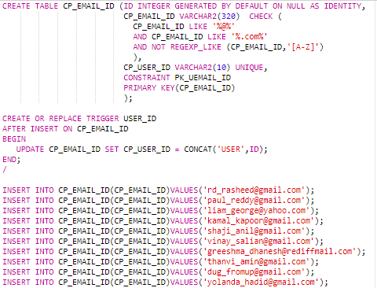

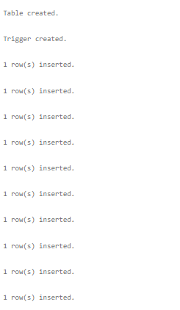

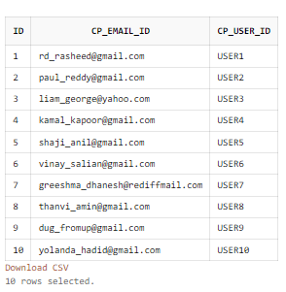

1. P_EMAIL_ID

CREATE TABLE P_EMAIL_ID (ID INTEGER GENERATED BY DEFAULT ON NULL AS IDENTITY,

P_POL_ID VARCHAR2(10),

P_EMAIL_ID VARCHAR2(320) CHECK (

P_EMAIL_ID LIKE '%@%'

AND P_EMAIL_ID LIKE '%.com%'

AND NOT REGEXP_LIKE (P_EMAIL_ID,'[A-Z]')

),

CONSTRAINT PK_PEMAIL_ID

PRIMARY KEY (P_EMAIL_ID)

);

CREATE OR REPLACE TRIGGER POL_ID

AFTER INSERT ON P_EMAIL_ID

BEGIN

UPDATE P_EMAIL_ID SET P_POL_ID = CONCAT('POL',ID);

INSERT INTO CP_EMAIL_ID(CP_EMAIL_ID) SELECT P_EMAIL_ID FROM P_EMAIL_ID WHERE

P_EMAIL_ID NOT IN ( SELECT CP_EMAIL_ID FROM CP_EMAIL_ID) ;

END;

/

INSERT INTO P_EMAIL_ID(P_EMAIL_ID)VALUES('riyask@gmail.com');

INSERT INTO P_EMAIL_ID(P_EMAIL_ID)VALUES('milyblunt@gmail.com');

INSERT INTO P_EMAIL_ID(P_EMAIL_ID)VALUES('joegoldburg@yahoo.com');

INSERT INTO P_EMAIL_ID(P_EMAIL_ID)VALUES('shatri_salian@gmail.com');

INSERT INTO P_EMAIL_ID(P_EMAIL_ID)VALUES('lakshmi_kp@gmail.com');

INSERT INTO P_EMAIL_ID(P_EMAIL_ID)VALUES('athira_ar@rediff.com');

INSERT INTO P_EMAIL_ID(P_EMAIL_ID)VALUES('kendal_jenner@gmail.com');

INSERT INTO P_EMAIL_ID(P_EMAIL_ID)VALUES('kylie_jenner@gmail.com');

INSERT INTO P_EMAIL_ID(P_EMAIL_ID)VALUES('travis_scott@gmail.com');

INSERT INTO P_EMAIL_ID(P_EMAIL_ID)VALUES('chris_evans@gmail.com');

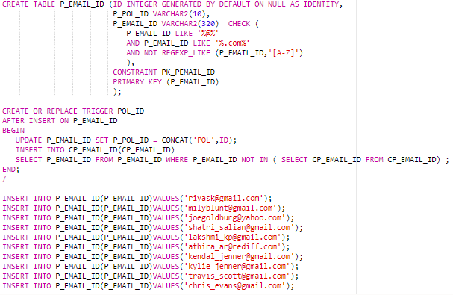

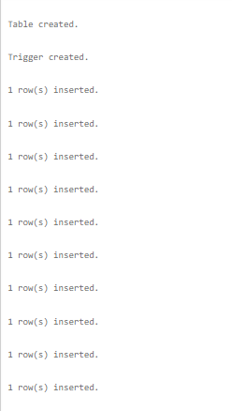

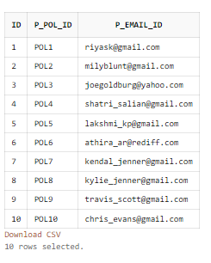

UPDATED CP_EMAIL_ID TABLE:

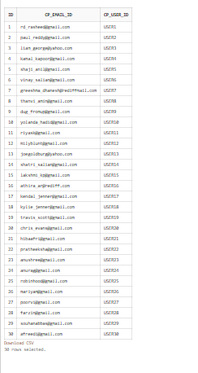

1. D_EMAIL_ID

CREATE TABLE D_EMAIL_ID (ID INTEGER GENERATED BY DEFAULT ON NULL AS IDENTITY,

D_DOC_ID VARCHAR2(10),

D_EMAIL_ID VARCHAR2(320) CHECK (

D_EMAIL_ID LIKE '%@%'

AND D_EMAIL_ID LIKE '%.com%'

AND NOT REGEXP_LIKE (D_EMAIL_ID,'[A-Z]')

),

CONSTRAINT PK_DEMAIL_ID

PRIMARY KEY (D_EMAIL_ID)

);

CREATE OR REPLACE TRIGGER DOL_ID

AFTER INSERT ON D_EMAIL_ID

BEGIN

UPDATE D_EMAIL_ID SET D_DOC_ID = CONCAT('DOC', ID);

INSERT INTO CP_EMAIL_ID(CP_EMAIL_ID) SELECT D_EMAIL_ID FROM D_EMAIL_ID WHERE D_EMAIL_ID NOT IN ( SELECT CP_EMAIL_ID FROM CP_EMAIL_ID) ;

END;

/

INSERT INTO D_EMAIL_ID(D_EMAIL_ID) VALUES('hibaafri@gmail.com');

INSERT INTO D_EMAIL_ID(D_EMAIL_ID) VALUES('pratheeksha@gmail.com');

INSERT INTO D_EMAIL_ID(D_EMAIL_ID) VALUES('anushree@gmail.com');

INSERT INTO D_EMAIL_ID(D_EMAIL_ID) VALUES('anurag@gmail.com');

INSERT INTO D_EMAIL_ID(D_EMAIL_ID) VALUES('robinhood@gmail.com');

INSERT INTO D_EMAIL_ID(D_EMAIL_ID) VALUES('mariyam@gmail.com');

INSERT INTO D_EMAIL_ID(D_EMAIL_ID) VALUES('poorvi@gmail.com');

INSERT INTO D_EMAIL_ID(D_EMAIL_ID) VALUES('farzin@gmail.com');

INSERT INTO D_EMAIL_ID(D_EMAIL_ID) VALUES('souhanabbas@gmail.com');

INSERT INTO D_EMAIL_ID(D_EMAIL_ID) VALUES('afreedi@gmail.com');

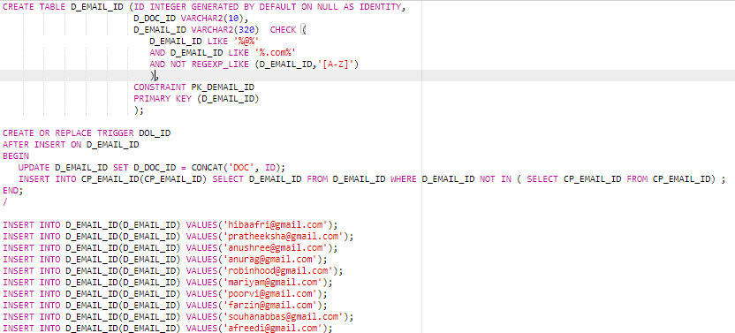

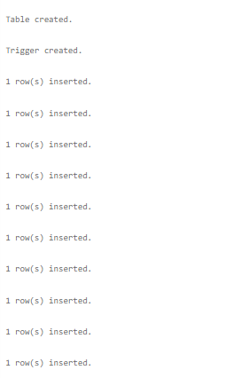

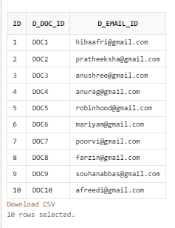

UPDATED CP_EMAIL_ID TABLE:



1. CP_LOGIN

CREATE TABLE CP_LOGIN (CP_LOGIN_ID VARCHAR2(320) NOT NULL,

CP_DATE_TIME TIMESTAMP DEFAULT CURRENT_TIMESTAMP NOT NULL,

CONSTRAINT PK_CP_LOGIN

PRIMARY KEY (CP_LOGIN_ID, CP_DATE_TIME),

FOREIGN KEY(CP_LOGIN_ID)

REFERENCES CP_EMAIL_ID(CP_EMAIL_ID)

);

INSERT INTO CP_LOGIN(CP_LOGIN_ID)VALUES('liam_george@yahoo.com');

INSERT INTO CP_LOGIN(CP_LOGIN_ID)VALUES('paul_reddy@gmail.com');

INSERT INTO CP_LOGIN(CP_LOGIN_ID)VALUES('rd_rasheed@gmail.com');

INSERT INTO CP_LOGIN(CP_LOGIN_ID)VALUES('shaji_anil@gmail.com');

INSERT INTO CP_LOGIN(CP_LOGIN_ID)VALUES('kamal_kapoor@gmail.com');

INSERT INTO CP_LOGIN(CP_LOGIN_ID)VALUES('vinay_salian@gmail.com');

INSERT INTO CP_LOGIN(CP_LOGIN_ID)VALUES('dug_fromup@gmail.com');

INSERT INTO CP_LOGIN(CP_LOGIN_ID)VALUES('thanvi_amin@gmail.com');

INSERT INTO CP_LOGIN(CP_LOGIN_ID)VALUES('dug_fromup@gmail.com');

INSERT INTO CP_LOGIN(CP_LOGIN_ID)VALUES('thanvi_amin@gmail.com');

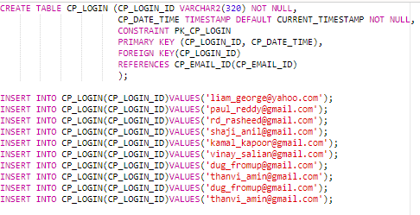

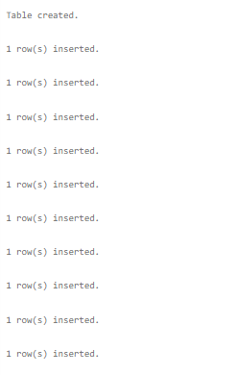

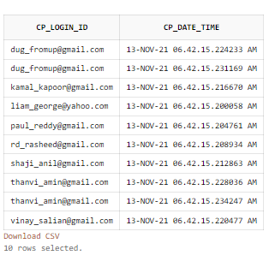

1. CP_DETAILS

CREATE TABLE CP_DETAILS (CP_EMAIL_ID VARCHAR2(320) NOT NULL,

CP_PASSWORD VARCHAR2(100) NOT NULL CHECK (

REGEXP_LIKE (CP_PASSWORD,'[a-z]')

AND REGEXP_LIKE (CP_PASSWORD,'[A-Z]')

AND REGEXP_LIKE (CP_PASSWORD,'[0-9]')

AND LENGTH(CP_PASSWORD)>8

),

CP_NAME VARCHAR2(100) NOT NULL,

CP_GENDER VARCHAR2(6) NOT NULL,

CP_ADDRESS VARCHAR2(100) NOT NULL,

CP_DOB DATE NOT NULL,

CP_AGE INT,

CP_TOTAL_PENALTY INT NOT NULL,

MED_HEIGHT FLOAT NOT NULL,

MED_WEIGHT FLOAT,

MED_BLOOD_GROUP VARCHAR2(10) NOT NULL,

FOREIGN KEY (CP_EMAIL_ID)

REFERENCES CP_EMAIL_ID(CP_EMAIL_ID)

);

CREATE OR REPLACE TRIGGER AGE

AFTER INSERT ON CP_DETAILS

BEGIN

UPDATE CP_DETAILS SET CP_AGE = (TO_CHAR(SYSDATE,'YYYY') - (EXTRACT(YEAR FROM

CP_DOB)));

END;

/

CREATE UNIQUE INDEX I_CP_DETAILS ON CP_DETAILS (CP_EMAIL_ID);

INSERT INTO CP_DETAILS(CP_EMAIL_ID , CP_PASSWORD, CP_NAME, CP_GENDER, CP_ADDRESS, CP_DOB, CP_TOTAL_PENALTY, MED_HEIGHT, MED_WEIGHT, MED_BLOOD_GROUP) VALUES('rd_rasheed@gmail.com', 'AB12345bc', 'RASHEED R D', 'MALE', 'RASH HOUSE NO.22 BHANDRA MUMBAI', to_date('12-09-1998','dd-mm-yyyy'), 800, 180, 72, 'A+');

INSERT INTO CP_DETAILS(CP_EMAIL_ID , CP_PASSWORD, CP_NAME, CP_GENDER, CP_ADDRESS, CP_DOB, CP_TOTAL_PENALTY, MED_HEIGHT, MED_WEIGHT, MED_BLOOD_GROUP) VALUES('paul_reddy@gmail.com', 'AB12345bc', 'PAUL REDDY', 'MALE', 'RASH HOUSE NO.20 BHANDRA MUMBAI', to_date('12-06-1998','dd-mm-yyyy'), 900, 179, 77, 'A+');

INSERT INTO CP_DETAILS(CP_EMAIL_ID , CP_PASSWORD, CP_NAME, CP_GENDER, CP_ADDRESS, CP_DOB, CP_TOTAL_PENALTY, MED_HEIGHT, MED_WEIGHT, MED_BLOOD_GROUP) VALUES('liam_george@yahoo.com', 'AMEN89shi', 'LIAM GEORGE', 'MALE', 'RASH HOUSE NO.11 BHANDRA MUMBAI', to_date('09-04-1997','dd-mm-yyyy'), 70, 165, 80, 'B+');

INSERT INTO CP_DETAILS(CP_EMAIL_ID , CP_PASSWORD, CP_NAME, CP_GENDER, CP_ADDRESS, CP_DOB, CP_TOTAL_PENALTY, MED_HEIGHT, MED_WEIGHT, MED_BLOOD_GROUP) VALUES('kamal_kapoor@gmail.com', 'oum907GEETH', 'KAMAL KAPOOR', 'MALE', 'NINA HOUSING COLONY NO 44 BHANDRA MUMBAI', to_date('10-02-2002','dd-mm-yyyy'), 500, 186, 69, 'O+');

INSERT INTO CP_DETAILS(CP_EMAIL_ID , CP_PASSWORD, CP_NAME, CP_GENDER, CP_ADDRESS, CP_DOB, CP_TOTAL_PENALTY, MED_HEIGHT, MED_WEIGHT, MED_BLOOD_GROUP) VALUES('shaji_anil@gmail.com', 'shaj69SUDEENDRA', 'SHAJI ANIL', 'MALE', 'LILY HOUSING COLONY NO.56 KANNUR KERALA', to_date('12-09-1995','dd-mm-yyyy'), 890, 150, 82, 'O-');

INSERT INTO CP_DETAILS(CP_EMAIL_ID , CP_PASSWORD, CP_NAME, CP_GENDER, CP_ADDRESS, CP_DOB, CP_TOTAL_PENALTY, MED_HEIGHT, MED_WEIGHT, MED_BLOOD_GROUP) VALUES('vinay_salian@gmail.com', 'TUBE69light', 'VINAY SALIAN', 'MALE', 'BHANDARA HOUSE NO 44 MUKHA KARNATAKA', to_date('10-02-2002','dd-mm-yyyy'), 7500, 183, 70, 'O+');

INSERT INTO CP_DETAILS(CP_EMAIL_ID , CP_PASSWORD, CP_NAME, CP_GENDER, CP_ADDRESS, CP_DOB, CP_TOTAL_PENALTY, MED_HEIGHT, MED_WEIGHT, MED_BLOOD_GROUP) VALUES('greeshma_dhanesh@rediffmail.com', 'GREESH78ma', 'GREESHMA DHANESH', 'FEMALE', 'GREEN HOUSE NO.02 NASIK MUMBAI', to_date('11-12-1993','dd-mm-yyyy'), 690, 156, 52, 'A+');

INSERT INTO CP_DETAILS(CP_EMAIL_ID , CP_PASSWORD, CP_NAME, CP_GENDER, CP_ADDRESS, CP_DOB, CP_TOTAL_PENALTY, MED_HEIGHT, MED_WEIGHT, MED_BLOOD_GROUP) VALUES('thanvi_amin@gmail.com', 'VI345678nuuu', 'THANVI AMIN', 'FEMALE', 'KENJ HOUSE NO 45 SURATHKAL KARNATAKA', to_date('22-03-2001','dd-mm-yyyy'), 89900, 149, 90, 'B-');

INSERT INTO CP_DETAILS(CP_EMAIL_ID , CP_PASSWORD, CP_NAME, CP_GENDER, CP_ADDRESS, CP_DOB, CP_TOTAL_PENALTY, MED_HEIGHT, MED_WEIGHT, MED_BLOOD_GROUP) VALUES('dug_fromup@gmail.com','golden20RETR', 'CARL DCRUIZ', 'MALE', 'ROSE HOUSE NO.09 BHANDRA MUMBAI', to_date('10-09-1998','dd-mm-yyyy'), 900, 160, 72, 'AB-' );

INSERT INTO CP_DETAILS(CP_EMAIL_ID , CP_PASSWORD, CP_NAME, CP_GENDER, CP_ADDRESS, CP_DOB, CP_TOTAL_PENALTY, MED_HEIGHT, MED_WEIGHT, MED_BLOOD_GROUP) VALUES('yolanda_hadid@gmail.com', 'TOXIC09mom', 'YOLANDA HADID', 'FEMALE', 'RASH HOUSE NO.29 MALLESHWAR MUMBAI', to_date('13-08-1972','dd-mm-yyyy'), 880, 178, 90, 'A+');

INSERT INTO CP_DETAILS(CP_EMAIL_ID , CP_PASSWORD, CP_NAME, CP_GENDER, CP_ADDRESS, CP_DOB, CP_TOTAL_PENALTY, MED_HEIGHT, MED_WEIGHT, MED_BLOOD_GROUP) VALUES('riyask@gmail.com', 'rIyask11SK', 'RIYAS', 'FEMALE', ' GANDHI NAGAR TN', to_date('22-03-2001','dd-mm-yyyy'), 800, 149, 90, 'B-');

INSERT INTO CP_DETAILS(CP_EMAIL_ID , CP_PASSWORD, CP_NAME, CP_GENDER, CP_ADDRESS, CP_DOB, CP_TOTAL_PENALTY, MED_HEIGHT, MED_WEIGHT, MED_BLOOD_GROUP) VALUES('milyblunt@gmail.com', 'VI345678uuu', 'MILY BLUNT', 'FEMALE', 'ENRATHKAL KERALA', to_date('21-12-2002','dd-mm-yyyy'), 800, 149, 90, 'B+');

INSERT INTO CP_DETAILS(CP_EMAIL_ID , CP_PASSWORD, CP_NAME, CP_GENDER, CP_ADDRESS, CP_DOB, CP_TOTAL_PENALTY, MED_HEIGHT, MED_WEIGHT, MED_BLOOD_GROUP) VALUES('joegoldburg@yahoo.com', 'VI345678nuu', 'JEOGOLD BURG', 'MALE', 'KENKAL KARNATAKA', to_date('12-01-2001','dd-mm-yyyy'), 890, 149, 90, 'A-');

INSERT INTO CP_DETAILS(CP_EMAIL_ID , CP_PASSWORD, CP_NAME, CP_GENDER, CP_ADDRESS, CP_DOB, CP_TOTAL_PENALTY, MED_HEIGHT, MED_WEIGHT, MED_BLOOD_GROUP) VALUES('shatri_salian@gmail.com', 'VI45678nuuu', 'SHATRI', 'FEMALE', 'HOUSE NO 45 ANNA NAGAR TN', to_date('02-02-1999','dd-mm-yyyy'), 8900, 149, 90, 'A+');

INSERT INTO CP_DETAILS(CP_EMAIL_ID , CP_PASSWORD, CP_NAME, CP_GENDER, CP_ADDRESS, CP_DOB, CP_TOTAL_PENALTY, MED_HEIGHT, MED_WEIGHT, MED_BLOOD_GROUP) VALUES('hibaafri@gmail.com', 'VI345678nuu', 'HIBAAFRI', 'MALE', 'SURATH KERALA', to_date('22-03-1999','dd-mm-yyyy'), 8990, 149, 90, 'AB-');

INSERT INTO CP_DETAILS(CP_EMAIL_ID , CP_PASSWORD, CP_NAME, CP_GENDER, CP_ADDRESS, CP_DOB, CP_TOTAL_PENALTY, MED_HEIGHT, MED_WEIGHT, MED_BLOOD_GROUP) VALUES('anushree@gmail.com', 'VI34568nuuu', 'ANUSHREE', 'FEMALE', 'K.K NAGAR KARNATAKA', to_date('12-03-1986','dd-mm-yyyy'), 9900, 149, 90, 'O');

INSERT INTO CP_DETAILS(CP_EMAIL_ID , CP_PASSWORD, CP_NAME, CP_GENDER, CP_ADDRESS, CP_DOB, CP_TOTAL_PENALTY, MED_HEIGHT, MED_WEIGHT, MED_BLOOD_GROUP) VALUES('anurag@gmail.com', 'V345678nuuu', 'ANURAG', 'MALE', 'KENJ SURATHKAL TN', to_date('02-04-1972','dd-mm-yyyy'), 899, 145, 98, 'O-');

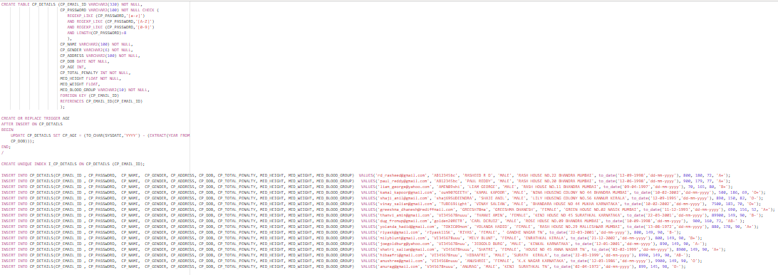

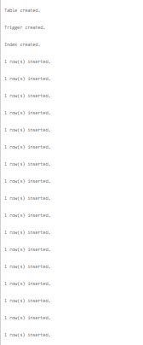

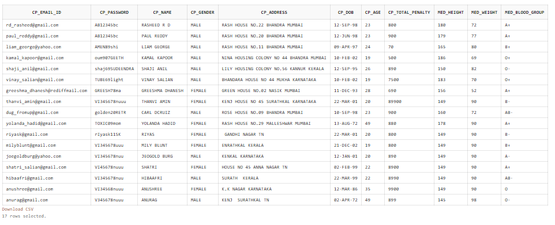

1. CP_AADHAAR

CREATE TABLE CP_AADHAAR (CP_EMAIL_ID VARCHAR2(320) UNIQUE NOT NULL,

CP_AADHAAR_NO INT CHECK (

LENGTH(CP_AADHAAR_NO)=12

),

PRIMARY KEY(CP_AADHAAR_NO),

FOREIGN KEY(CP_EMAIL_ID)

REFERENCES CP_EMAIL_ID(CP_EMAIL_ID)

);

INSERT INTO CP_AADHAAR(CP_EMAIL_ID, CP_AADHAAR_NO)VALUES('rd_rasheed@gmail.com', 213476598701);

INSERT INTO CP_AADHAAR(CP_EMAIL_ID, CP_AADHAAR_NO)VALUES('paul_reddy@gmail.com', 123456098744);

INSERT INTO CP_AADHAAR(CP_EMAIL_ID, CP_AADHAAR_NO)VALUES('liam_george@yahoo.com', 198712345688);

INSERT INTO CP_AADHAAR(CP_EMAIL_ID, CP_AADHAAR_NO)VALUES('kamal_kapoor@gmail.com', 319283746501);

INSERT INTO CP_AADHAAR(CP_EMAIL_ID, CP_AADHAAR_NO)VALUES('shaji_anil@gmail.com', 123456789089 );

INSERT INTO CP_AADHAAR(CP_EMAIL_ID, CP_AADHAAR_NO)VALUES('vinay_salian@gmail.com', 919283746529);

INSERT INTO CP_AADHAAR(CP_EMAIL_ID, CP_AADHAAR_NO)VALUES('greeshma_dhanesh@rediffmail.com', 678905431279);

INSERT INTO CP_AADHAAR(CP_EMAIL_ID, CP_AADHAAR_NO)VALUES('thanvi_amin@gmail.com', 102938476519);

INSERT INTO CP_AADHAAR(CP_EMAIL_ID, CP_AADHAAR_NO)VALUES('dug_fromup@gmail.com', 110093847637);

INSERT INTO CP_AADHAAR(CP_EMAIL_ID, CP_AADHAAR_NO)VALUES('yolanda_hadid@gmail.com', 278993467821);

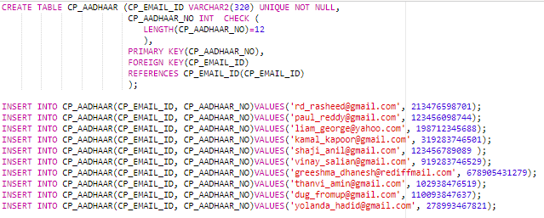

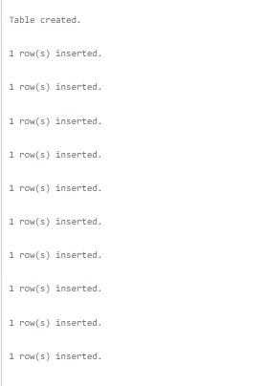

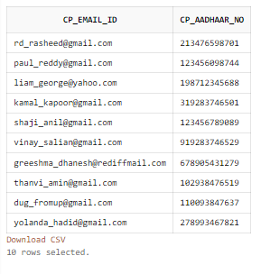

1. C_CRIME

CREATE TABLE C_CRIME (CP_EMAIL_ID VARCHAR2(320) NOT NULL,

C_PHONE_NO INT NOT NULL CHECK (

LENGTH(C_PHONE_NO)=10

),

C_LOCATION VARCHAR2(1000) NOT NULL,

C_DATE_TIME TIMESTAMP DEFAULT CURRENT_TIMESTAMP NOT

NULL,

PRIMARY KEY(CP_EMAIL_ID,C_DATE_TIME),

FOREIGN KEY(CP_EMAIL_ID)

REFERENCES CP_EMAIL_ID(CP_EMAIL_ID)

);

INSERT INTO C_CRIME(CP_EMAIL_ID, C_PHONE_NO, C_LOCATION) VALUES('rd_rasheed@gmail.com', 8927653911, 'CHINMAYA COLONY VIDYANAGAR KASARGOD KERALA');

INSERT INTO C_CRIME(CP_EMAIL_ID, C_PHONE_NO, C_LOCATION) VALUES('paul_reddy@gmail.com', 7891234567, 'MG ROAD BHANDRA MUMBAI MAHARASHTRA');

INSERT INTO C_CRIME(CP_EMAIL_ID, C_PHONE_NO, C_LOCATION) VALUES('liam_george@yahoo.com', 7891234587, 'ZAYED ROAD VHIDH MUMBAI MAHARASHTRA');

INSERT INTO C_CRIME(CP_EMAIL_ID, C_PHONE_NO, C_LOCATION) VALUES('kamal_kapoor@gmail.com', 9091234580, 'BALE ROAD VHIDH KOZHIKOD KERALA');

INSERT INTO C_CRIME(CP_EMAIL_ID, C_PHONE_NO, C_LOCATION) VALUES('shaji_anil@gmail.com', 8891234580, 'GREEN HILL SCHOOL KOZHIKOD KERALA');

INSERT INTO C_CRIME(CP_EMAIL_ID, C_PHONE_NO, C_LOCATION) VALUES('vinay_salian@gmail.com', 1234509877, 'LITTLE FLOWERS SCHOOL MANIPAL KARNATAKA');

INSERT INTO C_CRIME(CP_EMAIL_ID, C_PHONE_NO, C_LOCATION) VALUES('greeshma_dhanesh@rediffmail.com', 9034509877, 'LITTLE HILL ROAD MANGLORE KARNATAKA');

INSERT INTO C_CRIME(CP_EMAIL_ID, C_PHONE_NO, C_LOCATION) VALUES('dug_fromup@gmail.com', 9088509877, 'POST OFFICE MANAYA MYSORE KARNATAKA');

INSERT INTO C_CRIME(CP_EMAIL_ID, C_PHONE_NO, C_LOCATION) VALUES('yolanda_hadid@gmail.com', 9088709890, 'POST OFFICE DHAAYA UDUPI KARNATAKA');

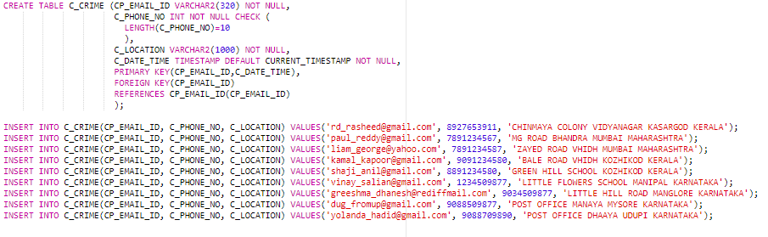

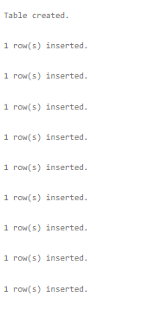

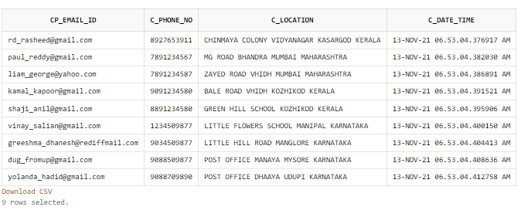

1. CRIME_DETAILS

CREATE TABLE CRIME_DETAILS (PEN_CRIME_COMMITTED VARCHAR2(250) NOT NULL,

PEN_PENALITY INT NOT NULL,

CONSTRAINT PK_CRIME_DETAILS

PRIMARY KEY(PEN_CRIME_COMMITTED)

);

INSERT INTO CRIME_DETAILS VALUES('MURDER', 120000);

INSERT INTO CRIME_DETAILS VALUES('ROBBERY', 20000);

INSERT INTO CRIME_DETAILS VALUES('NO HELMET', 500);

INSERT INTO CRIME_DETAILS VALUES('NO SEAT BELT', 800);

INSERT INTO CRIME_DETAILS VALUES('ASSAULT', 900);

INSERT INTO CRIME_DETAILS VALUES('SHOPLIFTING', 500);

INSERT INTO CRIME_DETAILS VALUES('KIDNAPING', 10000);

INSERT INTO CRIME_DETAILS VALUES('VANDALISM', 500);

INSERT INTO CRIME_DETAILS VALUES('VIOLENT CRIMES', 100000);

INSERT INTO CRIME_DETAILS VALUES('FRAUD', 1000);

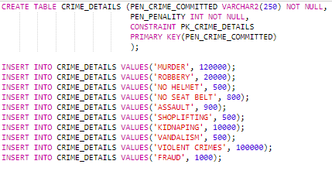

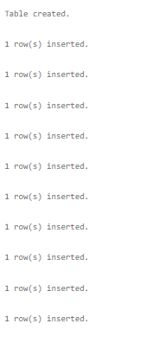

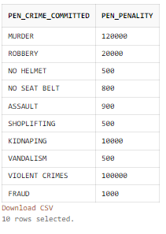

1. C_PENALITY

CREATE TABLE C_PENALITY (PEN_CP_EMAIL_ID VARCHAR2(320) NOT NULL,

PEN_EMAIL_ID VARCHAR2(320) NOT NULL,

PEN_DATE_TIME TIMESTAMP DEFAULT CURRENT_TIMESTAMP NOT NULL,

PEN_CRIME_COMMITTED VARCHAR2(250) NOT NULL, PEN_PAID_OR_NOT VARCHAR2(5) NOT NULL CHECK (

PEN_PAID_OR_NOT LIKE '%YES%'

OR PEN_PAID_OR_NOT LIKE '%NO%'

),

FOREIGN KEY(PEN_CP_EMAIL_ID)

REFERENCES CP_EMAIL_ID(CP_EMAIL_ID),

FOREIGN KEY(PEN_EMAIL_ID)

REFERENCES P_EMAIL_ID(P_EMAIL_ID),

FOREIGN KEY(PEN_CRIME_COMMITTED)

REFERENCES CRIME_DETAILS(PEN_CRIME_COMMITTED)

);

INSERT INTO C_PENALITY(PEN_CP_EMAIL_ID, PEN_EMAIL_ID, PEN_CRIME_COMMITTED, PEN_PAID_OR_NOT) VALUES('rd_rasheed@gmail.com', 'riyask@gmail.com', 'NO HELMET', 'YES');

INSERT INTO C_PENALITY(PEN_CP_EMAIL_ID, PEN_EMAIL_ID, PEN_CRIME_COMMITTED, PEN_PAID_OR_NOT) VALUES('paul_reddy@gmail.com', 'milyblunt@gmail.com', 'ROBBERY', 'YES');

INSERT INTO C_PENALITY(PEN_CP_EMAIL_ID, PEN_EMAIL_ID, PEN_CRIME_COMMITTED , PEN_PAID_OR_NOT) VALUES('kamal_kapoor@gmail.com', 'shatri_salian@gmail.com', 'ROBBERY', 'NO');

INSERT INTO C_PENALITY(PEN_CP_EMAIL_ID, PEN_EMAIL_ID, PEN_CRIME_COMMITTED , PEN_PAID_OR_NOT) VALUES('shaji_anil@gmail.com', 'lakshmi_kp@gmail.com', 'NO SEAT BELT', 'NO');

INSERT INTO C_PENALITY(PEN_CP_EMAIL_ID, PEN_EMAIL_ID, PEN_CRIME_COMMITTED , PEN_PAID_OR_NOT) VALUES('vinay_salian@gmail.com', 'athira_ar@rediff.com', 'FRAUD', 'NO');

INSERT INTO C_PENALITY(PEN_CP_EMAIL_ID, PEN_EMAIL_ID, PEN_CRIME_COMMITTED , PEN_PAID_OR_NOT ) VALUES('greeshma_dhanesh@rediffmail.com', 'kendal_jenner@gmail.com', 'NO HELMET', 'NO');

INSERT INTO C_PENALITY(PEN_CP_EMAIL_ID, PEN_EMAIL_ID, PEN_CRIME_COMMITTED , PEN_PAID_OR_NOT) VALUES('thanvi_amin@gmail.com', 'kylie_jenner@gmail.com', 'SHOPLIFTING', 'YES');

INSERT INTO C_PENALITY(PEN_CP_EMAIL_ID, PEN_EMAIL_ID, PEN_CRIME_COMMITTED , PEN_PAID_OR_NOT ) VALUES('dug_fromup@gmail.com', 'travis_scott@gmail.com', 'FRAUD', 'YES');

INSERT INTO C_PENALITY(PEN_CP_EMAIL_ID, PEN_EMAIL_ID, PEN_CRIME_COMMITTED , PEN_PAID_OR_NOT ) VALUES('yolanda_hadid@gmail.com', 'chris_evans@gmail.com', 'ROBBERY', 'YES');

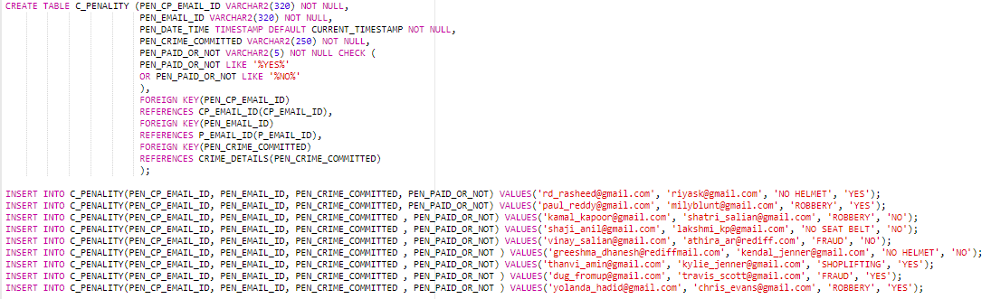

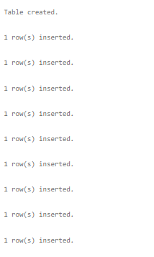

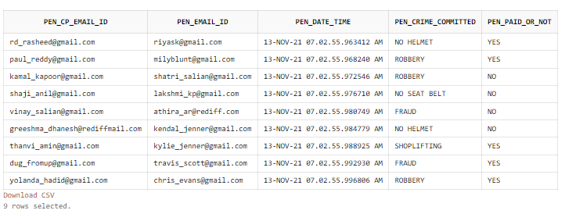

1. AMB_DETAILS

CREATE TABLE AMB_DETAILS (A_EMAIL_ID VARCHAR2(320) NOT NULL,

A_PHONE_NO INT NOT NULL CHECK (

LENGTH(A_PHONE_NO)=10

) ,

A_DATE_TIME TIMESTAMP DEFAULT CURRENT_TIMESTAMP NOT NULL,

A_LOCATION VARCHAR2(1000) NOT NULL,

FOREIGN KEY(A_EMAIL_ID)

REFERENCES CP_EMAIL_ID(CP_EMAIL_ID),

PRIMARY KEY(A_EMAIL_ID,A_DATE_TIME)

);

INSERT INTO AMB_DETAILS(A_EMAIL_ID, A_PHONE_NO, A_LOCATION) VALUES('rd_rasheed@gmail.com',1122334455, 'MG ROAD BHANDRA MAHARASHTRA');

INSERT INTO AMB_DETAILS(A_EMAIL_ID, A_PHONE_NO, A_LOCATION) VALUES('paul_reddy@gmail.com', 9977553322, 'BC ROAD BHANDRAN MAHARASHTRA');

INSERT INTO AMB_DETAILS(A_EMAIL_ID, A_PHONE_NO, A_LOCATION) VALUES('liam_george@yahoo.com', 8877555443, 'MODI ROAD DELHI');

INSERT INTO AMB_DETAILS(A_EMAIL_ID, A_PHONE_NO, A_LOCATION) VALUES('kamal_kapoor@gmail.com', 7779995553, 'HILLY HILL MYSORE KARNATAKA');

INSERT INTO AMB_DETAILS(A_EMAIL_ID, A_PHONE_NO, A_LOCATION) VALUES('shaji_anil@gmail.com', 2226669898, 'MIMI SCHOOL COIMBATORE TAMIL NADU');

INSERT INTO AMB_DETAILS(A_EMAIL_ID, A_PHONE_NO, A_LOCATION) VALUES('vinay_salian@gmail.com', 7899877897, 'GIGI ROAD KOLKATA WEST BENGAL');

INSERT INTO AMB_DETAILS(A_EMAIL_ID, A_PHONE_NO, A_LOCATION) VALUES('greeshma_dhanesh@rediffmail.com', 3456543789, 'ZAYN ROAD KOLKATA WEST BENGAL');

INSERT INTO AMB_DETAILS(A_EMAIL_ID, A_PHONE_NO, A_LOCATION) VALUES('thanvi_amin@gmail.com', 8989787867, 'GHAZA ROAD MANGLORE KARNATAKA');

INSERT INTO AMB_DETAILS(A_EMAIL_ID, A_PHONE_NO, A_LOCATION) VALUES('dug_fromup@gmail.com', 9898987654, 'BC ROAD CHENNAI TAMIL NADU');

INSERT INTO AMB_DETAILS(A_EMAIL_ID, A_PHONE_NO, A_LOCATION) VALUES('yolanda_hadid@gmail.com', 8988665542, 'HALLO STREET BENGLORE KARNATAKA');

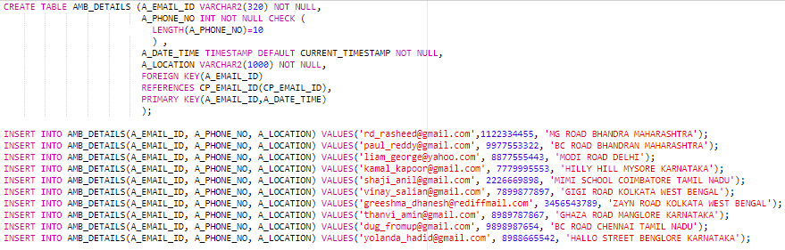

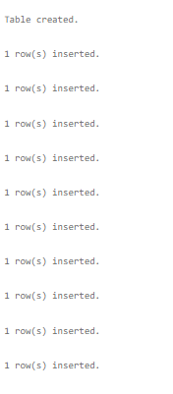

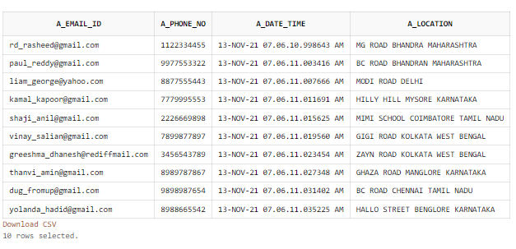

1. USER_ID_VEHICLE

CREATE TABLE USER_ID_VEHICLE (V_EMAIL_ID VARCHAR2(320) NOT NULL,

V_VEHICLE_NO VARCHAR2(16),

V_LICENSE_NO VARCHAR2(16),

FOREIGN KEY(V_EMAIL_ID)

REFERENCES CP_EMAIL_ID(CP_EMAIL_ID),

CONSTRAINT PK_VEHICLENO_LICENSENO

PRIMARY KEY (V_VEHICLE_NO,V_LICENSE_NO)

);

INSERT INTO USER_ID_VEHICLE(V_EMAIL_ID, V_VEHICLE_NO, V_LICENSE_NO) VALUES('rd_rasheed@gmail.com', 'KL14V1788', 'P33344448787');

INSERT INTO USER_ID_VEHICLE(V_EMAIL_ID, V_VEHICLE_NO, V_LICENSE_NO) VALUES('paul_reddy@gmail.com', 'KA19H1188', 'J99988887676');

INSERT INTO USER_ID_VEHICLE(V_EMAIL_ID, V_VEHICLE_NO, V_LICENSE_NO) VALUES('liam_george@yahoo.com', 'KL12I9090', 'O67600008799');

INSERT INTO USER_ID_VEHICLE(V_EMAIL_ID, V_VEHICLE_NO, V_LICENSE_NO) VALUES('kamal_kapoor@gmail.com', 'TN0B97777', 'H88897976543');

INSERT INTO USER_ID_VEHICLE(V_EMAIL_ID, V_VEHICLE_NO, V_LICENSE_NO) VALUES('shaji_anil@gmail.com', 'MH07K6888', 'J11187876565');

INSERT INTO USER_ID_VEHICLE(V_EMAIL_ID, V_VEHICLE_NO, V_LICENSE_NO) VALUES('vinay_salian@gmail.com','KA01L9899', 'F98907658766');

INSERT INTO USER_ID_VEHICLE(V_EMAIL_ID, V_VEHICLE_NO, V_LICENSE_NO) VALUES('greeshma_dhanesh@rediffmail.com', 'KL02P9090', 'K88823235656');

INSERT INTO USER_ID_VEHICLE(V_EMAIL_ID, V_VEHICLE_NO, V_LICENSE_NO) VALUES('thanvi_amin@gmail.com', 'KA01U7879', 'F99976765555');

INSERT INTO USER_ID_VEHICLE(V_EMAIL_ID, V_VEHICLE_NO, V_LICENSE_NO) VALUES('dug_fromup@gmail.com', 'KA03I0909', 'G66678791234');

INSERT INTO USER_ID_VEHICLE(V_EMAIL_ID, V_VEHICLE_NO, V_LICENSE_NO) VALUES('yolanda_hadid@gmail.com', 'KL09T6666', 'J99977774444');

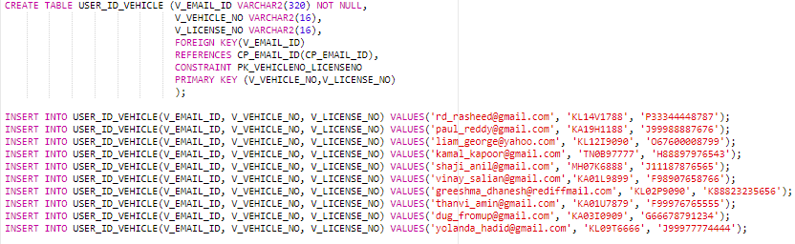

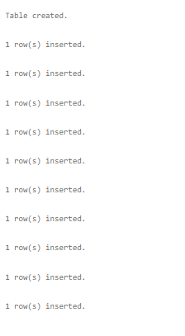

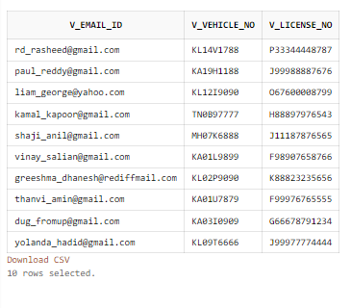

1. VEHICLE_DETAILS

CREATE TABLE VEHICLE_DETAILS (V_VEHICLE_NO VARCHAR2(16) NOT NULL,

V_VEHICLE_TYPE VARCHAR2(50) NOT NULL,

V_VEHICLE_NAME VARCHAR2(50) NOT NULL,

V_VEHICLE_COLOUR VARCHAR2(50) NOT NULL,

V_LICENSE_NO VARCHAR2(100) NOT NULL,

FOREIGN KEY(V_VEHICLE_NO,V_LICENSE_NO)

REFERENCES USER_ID_VEHICLE

(V_VEHICLE_NO,V_LICENSE_NO)

);

INSERT INTO VEHICLE_DETAILS(V_VEHICLE_NO, V_VEHICLE_TYPE, V_VEHICLE_NAME, V_VEHICLE_COLOUR, V_LICENSE_NO) VALUES('KL14V1788', 'CAR', 'BMW', 'RED', 'P33344448787');

INSERT INTO VEHICLE_DETAILS(V_VEHICLE_NO, V_VEHICLE_TYPE, V_VEHICLE_NAME, V_VEHICLE_COLOUR, V_LICENSE_NO) VALUES('KA19H1188', 'CAR', 'MARUTHI SUZUKI', 'BLUE', 'J99988887676');

INSERT INTO VEHICLE_DETAILS(V_VEHICLE_NO, V_VEHICLE_TYPE, V_VEHICLE_NAME, V_VEHICLE_COLOUR, V_LICENSE_NO) VALUES('KL12I9090', 'BIKE', 'BAJAJ', 'BLACK', 'O67600008799');

INSERT INTO VEHICLE_DETAILS(V_VEHICLE_NO, V_VEHICLE_TYPE, V_VEHICLE_NAME, V_VEHICLE_COLOUR, V_LICENSE_NO) VALUES('TN0B97777', 'BIKE', 'BAJAJ', 'WHITE', 'H88897976543');

INSERT INTO VEHICLE_DETAILS(V_VEHICLE_NO, V_VEHICLE_TYPE, V_VEHICLE_NAME, V_VEHICLE_COLOUR, V_LICENSE_NO) VALUES('MH07K6888', 'CAR', 'AUDI', 'BLACK', 'J11187876565');

INSERT INTO VEHICLE_DETAILS(V_VEHICLE_NO, V_VEHICLE_TYPE, V_VEHICLE_NAME, V_VEHICLE_COLOUR, V_LICENSE_NO) VALUES('KA01L9899', 'CAR', 'TATA', 'BLUE', 'F98907658766');

INSERT INTO VEHICLE_DETAILS(V_VEHICLE_NO, V_VEHICLE_TYPE, V_VEHICLE_NAME, V_VEHICLE_COLOUR, V_LICENSE_NO) VALUES('KL02P9090', 'SCOOTY', 'HONDAI', 'BLACK', 'K88823235656');

INSERT INTO VEHICLE_DETAILS(V_VEHICLE_NO, V_VEHICLE_TYPE, V_VEHICLE_NAME, V_VEHICLE_COLOUR, V_LICENSE_NO) VALUES('KA01U7879', 'SCOOTY', 'HONDAI', 'WHITE', 'F99976765555');

INSERT INTO VEHICLE_DETAILS(V_VEHICLE_NO, V_VEHICLE_TYPE, V_VEHICLE_NAME, V_VEHICLE_COLOUR, V_LICENSE_NO) VALUES('KA03I0909', 'CAR', 'PORSCHE', 'YELLOW', 'G66678791234');

INSERT INTO VEHICLE_DETAILS(V_VEHICLE_NO, V_VEHICLE_TYPE, V_VEHICLE_NAME, V_VEHICLE_COLOUR, V_LICENSE_NO) VALUES('KL09T6666', 'CAR', 'FORD', 'RED', 'J99977774444');

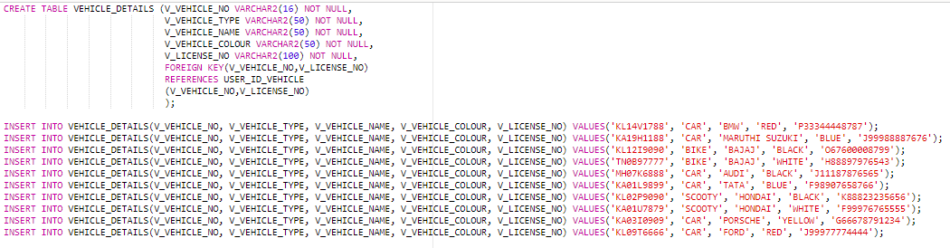

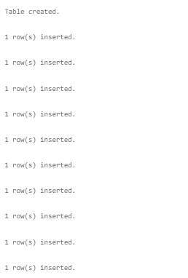

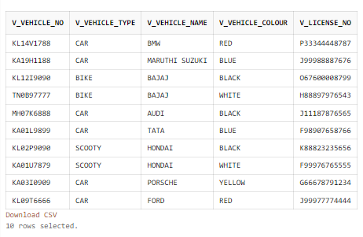

1. USER_ID_MINOR

CREATE TABLE USER_ID_MINOR (ID INT GENERATED BY DEFAULT ON NULL AS IDENTITY,

CP_EMAIL_ID VARCHAR2(320) NOT NULL,

MIN_MINOR_ID VARCHAR2(50) UNIQUE,

CONSTRAINT PK_USER_ID_MINOR

PRIMARY KEY(ID),

FOREIGN KEY(CP_EMAIL_ID)

REFERENCES CP_EMAIL_ID(CP_EMAIL_ID)

);

CREATE OR REPLACE TRIGGER MINOR_ID

AFTER INSERT ON USER_ID_MINOR

BEGIN

UPDATE USER_ID_MINOR SET MIN_MINOR_ID = CONCAT('MIN',ID);

END;

/

INSERT INTO USER_ID_MINOR(CP_EMAIL_ID) VALUES('rd_rasheed@gmail.com');

INSERT INTO USER_ID_MINOR(CP_EMAIL_ID) VALUES('paul_reddy@gmail.com');

INSERT INTO USER_ID_MINOR(CP_EMAIL_ID) VALUES('liam_george@yahoo.com');

INSERT INTO USER_ID_MINOR(CP_EMAIL_ID) VALUES('kamal_kapoor@gmail.com');

INSERT INTO USER_ID_MINOR(CP_EMAIL_ID) VALUES('shaji_anil@gmail.com');

INSERT INTO USER_ID_MINOR(CP_EMAIL_ID) VALUES('vinay_salian@gmail.com');

INSERT INTO USER_ID_MINOR(CP_EMAIL_ID) VALUES('greeshma_dhanesh@rediffmail.com');

INSERT INTO USER_ID_MINOR(CP_EMAIL_ID) VALUES('thanvi_amin@gmail.com');

INSERT INTO USER_ID_MINOR(CP_EMAIL_ID) VALUES('dug_fromup@gmail.com');

INSERT INTO USER_ID_MINOR(CP_EMAIL_ID) VALUES('yolanda_hadid@gmail.com');

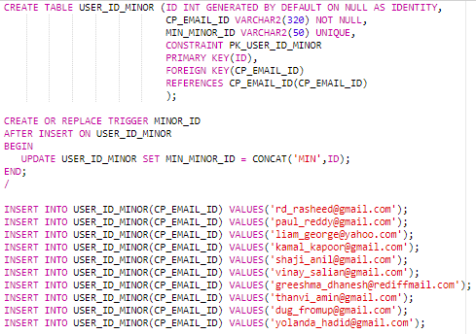

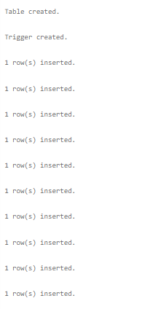

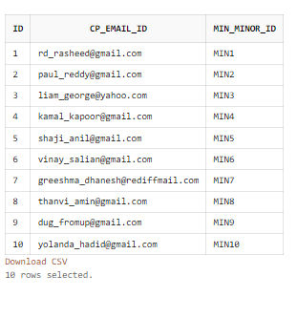

1. MINOR_DETAILS

CREATE TABLE MINOR_DETAILS (ID INT NOT NULL,

MIN_NAME VARCHAR2(100) NOT NULL,

MIN_GENDER VARCHAR2(10) NOT NULL,

MIN_DOB DATE NOT NULL,

MIN_AGE INT,

MMED_HEIGHT_CM FLOAT NOT NULL,

MMED_WEIGHT_KG FLOAT NOT NULL,

MMED_BLOOD_GROUP VARCHAR2(20) NOT NULL,

FOREIGN KEY(ID)

REFERENCES USER_ID_MINOR(ID)

);

CREATE OR REPLACE TRIGGER AGE_MINOR

AFTER INSERT ON MINOR_DETAILS

BEGIN

UPDATE MINOR_DETAILS SET MIN_AGE = (TO_CHAR(SYSDATE,'YYYY') - (EXTRACT(YEAR FROM

MIN_DOB)));

END;

/

CREATE UNIQUE INDEX I_MIN_DETAILS ON MINOR_DETAILS(ID);

INSERT INTO MINOR_DETAILS(ID, MIN_NAME, MIN_GENDER, MIN_DOB, MMED_HEIGHT_CM, MMED_WEIGHT_KG, MMED_BLOOD_GROUP) VALUES('1', 'KAREEN', 'MALE', to_date('12-12-2006','dd-mm-yyyy'), 150, 50, 'A+');

INSERT INTO MINOR_DETAILS(ID, MIN_NAME, MIN_GENDER, MIN_DOB, MMED_HEIGHT_CM, MMED_WEIGHT_KG, MMED_BLOOD_GROUP) VALUES('2', 'RIHANA', 'FEMALE', to_date('10-12-2008','dd-mm-yyyy'), 140, 39, 'A-');

INSERT INTO MINOR_DETAILS(ID, MIN_NAME, MIN_GENDER, MIN_DOB, MMED_HEIGHT_CM, MMED_WEIGHT_KG, MMED_BLOOD_GROUP) VALUES('3', 'RANA', 'MALE', to_date('12-11-2009','dd-mm-yyyy'), 150, 44, 'O+');

INSERT INTO MINOR_DETAILS(ID, MIN_NAME, MIN_GENDER, MIN_DOB, MMED_HEIGHT_CM, MMED_WEIGHT_KG, MMED_BLOOD_GROUP) VALUES('4', 'BHEEM', 'MAle', to_date('02-08-2005','dd-mm-yyyy'), 170, 55, 'B+');

INSERT INTO MINOR_DETAILS(ID, MIN_NAME, MIN_GENDER, MIN_DOB, MMED_HEIGHT_CM, MMED_WEIGHT_KG, MMED_BLOOD_GROUP) VALUES('5', 'RAM', 'MALE', to_date('10-12-2006','dd-mm-yyyy'), 180, 63, 'A+');

INSERT INTO MINOR_DETAILS(ID, MIN_NAME, MIN_GENDER, MIN_DOB, MMED_HEIGHT_CM, MMED_WEIGHT_KG, MMED_BLOOD_GROUP) VALUES('6', 'KENNY', 'FEMALE', to_date('19-02-2009','dd-mm-yyyy'), 144, 44, 'A-');

INSERT INTO MINOR_DETAILS(ID, MIN_NAME, MIN_GENDER, MIN_DOB, MMED_HEIGHT_CM, MMED_WEIGHT_KG, MMED_BLOOD_GROUP) VALUES('7', 'NINA', 'FEMALE', to_date('02-02-2005','dd-mm-yyyy'), 170, 66, 'O+');

INSERT INTO MINOR_DETAILS(ID, MIN_NAME, MIN_GENDER, MIN_DOB, MMED_HEIGHT_CM, MMED_WEIGHT_KG, MMED_BLOOD_GROUP) VALUES('8', 'DINA', 'FEMALE', to_date('12-12-2005','dd-mm-yyyy'), 178, 54, 'O-');

INSERT INTO MINOR_DETAILS(ID, MIN_NAME, MIN_GENDER, MIN_DOB, MMED_HEIGHT_CM, MMED_WEIGHT_KG, MMED_BLOOD_GROUP) VALUES('9', 'PRIYA', 'FEMALE', to_date('12-12-2010','dd-mm-yyyy'), 140, 36, 'A+');

INSERT INTO MINOR_DETAILS(ID, MIN_NAME, MIN_GENDER, MIN_DOB, MMED_HEIGHT_CM, MMED_WEIGHT_KG, MMED_BLOOD_GROUP) VALUES('10', 'STOR', 'MALE', to_date('11-08-2010','dd-mm-yyyy'), 149, 32, 'A+' );

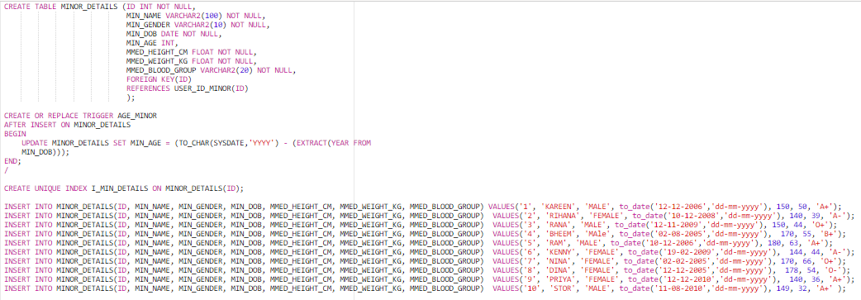



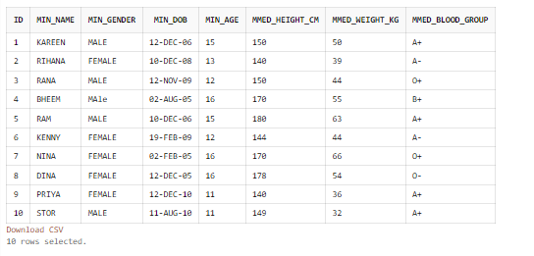

1. D_LOGIN

CREATE TABLE D_LOGIN (D_LOGIN_ID VARCHAR2(320),

D_DATE_TIME TIMESTAMP DEFAULT CURRENT_TIMESTAMP NOT

NULL,

CONSTRAINT PK_LOGIN

PRIMARY KEY (D_LOGIN_ID,D_DATE_TIME),

FOREIGN KEY(D_LOGIN_ID)

REFERENCES D_EMAIL_ID(D_EMAIL_ID)

);

INSERT INTO D_LOGIN(D_LOGIN_ID) VALUES('hibaafri@gmail.com');

INSERT INTO D_LOGIN(D_LOGIN_ID) VALUES('pratheeksha@gmail.com');

INSERT INTO D_LOGIN(D_LOGIN_ID) VALUES('anushree@gmail.com');

INSERT INTO D_LOGIN(D_LOGIN_ID) VALUES('anurag@gmail.com');

INSERT INTO D_LOGIN(D_LOGIN_ID) VALUES('robinhood@gmail.com');

INSERT INTO D_LOGIN(D_LOGIN_ID) VALUES('mariyam@gmail.com');

INSERT INTO D_LOGIN(D_LOGIN_ID) VALUES('poorvi@gmail.com');

INSERT INTO D_LOGIN(D_LOGIN_ID) VALUES('farzin@gmail.com');

INSERT INTO D_LOGIN(D_LOGIN_ID) VALUES('souhanabbas@gmail.com');

INSERT INTO D_LOGIN(D_LOGIN_ID) VALUES('afreedi@gmail.com');

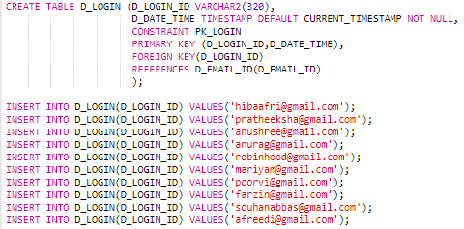

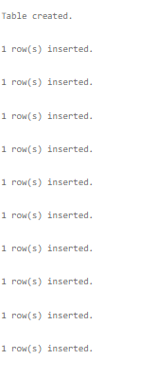

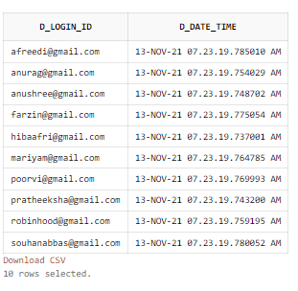

1. D_DETAILS

CREATE TABLE D_DETAILS (D_EMAIL_ID VARCHAR2(50) UNIQUE NOT NULL,

D_HOSPITAL_NAME VARCHAR2(50) NOT NULL,

D_QUALIFICATION VARCHAR2(50) NOT NULL,

D_EXPERIENCE INT NOT NULL,

D_SPECIALITY VARCHAR2(50) NOT NULL,

FOREIGN KEY(D_EMAIL_ID)

REFERENCES D_EMAIL_ID(D_EMAIL_ID)

);

INSERT INTO D_DETAILS VALUES('hibaafri@gmail.com', 'A J HOSPITAL', 'MBBS', 4, 'PEDIATRICIAN');

INSERT INTO D_DETAILS VALUES('pratheeksha@gmail.com', 'CITY HOSPITAL', 'MBBS', 5, 'PEDIATRICIAN');

INSERT INTO D_DETAILS VALUES('anushree@gmail.com', 'CAREWELL HOSPITAL', 'DMD', 3, 'DENTIST');

INSERT INTO D_DETAILS VALUES('anurag@gmail.com', 'LILY HOSPITAL', 'MD', 7, 'CARDIOLOGIST');

INSERT INTO D_DETAILS VALUES('robinhood@gmail.com', 'KMC HOSPITAL', 'MD', 6, 'NEUROLOGIST');

INSERT INTO D_DETAILS VALUES('mariyam@gmail.com', 'AJ HOSPITAL', 'MD', 3, 'PODIATRIST');

INSERT INTO D_DETAILS VALUES('poorvi@gmail.com', 'YENAPOYA HOSPITAL', 'MBBS', 1, 'ONCOLOGIST');

INSERT INTO D_DETAILS VALUES('farzin@gmail.com', 'MAHA HOSPITAL', 'MD', 8, 'CARDIOLOGY');

INSERT INTO D_DETAILS VALUES('souhanabbas@gmail.com', 'AMRITA HOSPITAL', 'MD', 4, 'NEUROLOGIST');

INSERT INTO D_DETAILS VALUES('afreedi@gmail.com', 'INDIANA HOSPITAL', 'MBBS', 2, 'NEUROLOGIST');

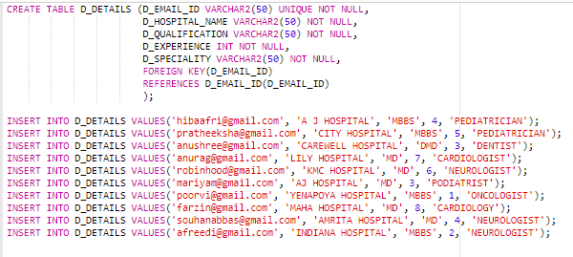

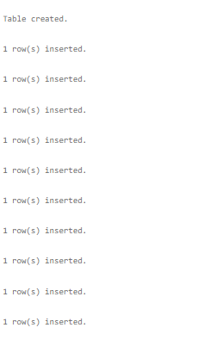

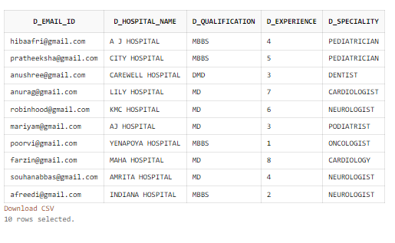

1. D_LICENSE

CREATE TABLE D_LICENSE (DL_LICENSE_ID VARCHAR2(50),

DL_ISSUED_DATE DATE NOT NULL,

CONSTRAINT PK_D_LICENSE

PRIMARY KEY(DL_LICENSE_ID)

);

INSERT INTO D_LICENSE VALUES('00AB1234', to_date('10-11-2009','dd-mm-yyyy'));

INSERT INTO D_LICENSE VALUES('11VD0987', to_date('12-01-2009','dd-mm-yyyy'));

INSERT INTO D_LICENSE VALUES('44BC5656', to_date('10-11-2010','dd-mm-yyyy'));

INSERT INTO D_LICENSE VALUES('56FB1234', to_date('15-03-2011','dd-mm-yyyy'));

INSERT INTO D_LICENSE VALUES('11RT5678', to_date('13-01-2013','dd-mm-yyyy'));

INSERT INTO D_LICENSE VALUES('34DV8787', to_date('10-01-2019','dd-mm-yyyy'));

INSERT INTO D_LICENSE VALUES('33VF5656', to_date('19-01-2009','dd-mm-yyyy'));

INSERT INTO D_LICENSE VALUES('89TY6565', to_date('18-06-2005','dd-mm-yyyy'));

INSERT INTO D_LICENSE VALUES('78GH2222', to_date('10-12-2010','dd-mm-yyyy'));

INSERT INTO D_LICENSE VALUES('90HU2457', to_date('08-01-2019','dd-mm-yyyy'));

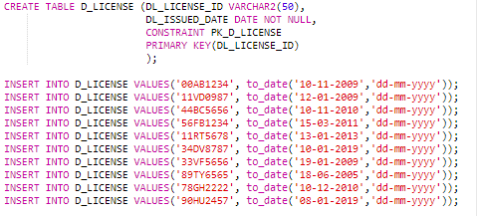

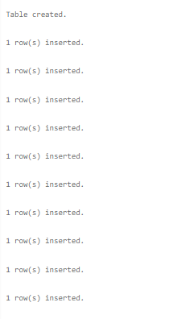

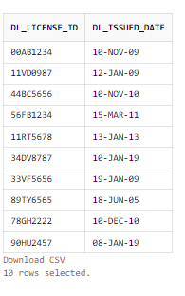

1. D_LICENSENO

CREATE TABLE D_LICENSENO (D_EMAIL_ID VARCHAR2(50) NOT NULL UNIQUE,

D_LICENSE_ID VARCHAR2(50) NOT NULL UNIQUE,

FOREIGN KEY(D_EMAIL_ID)

REFERENCES D_EMAIL_ID(D_EMAIL_ID),

FOREIGN KEY(D_LICENSE_ID)

REFERENCES D_LICENSE(DL_LICENSE_ID)

);

INSERT INTO D_LICENSENO VALUES('hibaafri@gmail.com', '00AB1234');

INSERT INTO D_LICENSENO VALUES('pratheeksha@gmail.com', '11VD0987');

INSERT INTO D_LICENSENO VALUES('anushree@gmail.com', '44BC5656');

INSERT INTO D_LICENSENO VALUES('anurag@gmail.com', '56FB1234');

INSERT INTO D_LICENSENO VALUES('robinhood@gmail.com', '11RT5678');

INSERT INTO D_LICENSENO VALUES('mariyam@gmail.com', '34DV8787');

INSERT INTO D_LICENSENO VALUES('poorvi@gmail.com', '33VF5656' );

INSERT INTO D_LICENSENO VALUES('farzin@gmail.com', '89TY6565');

INSERT INTO D_LICENSENO VALUES('souhanabbas@gmail.com', '78GH2222');

INSERT INTO D_LICENSENO VALUES('afreedi@gmail.com', '90HU2457');

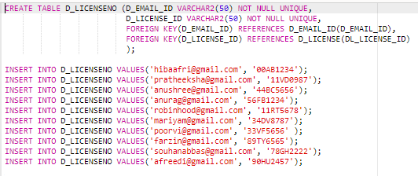

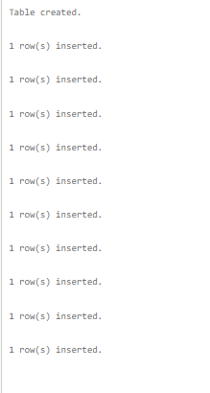

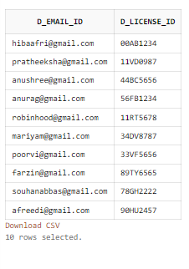

1. CP_PHONE

CREATE TABLE CP_PHONE (CP_EMAIL_ID VARCHAR2(320) NOT NULL UNIQUE,

CP_PHONE_NO INT NOT NULL CHECK(

LENGTH(CP_PHONE_NO)=10

) ,

FOREIGN KEY(CP_EMAIL_ID)

REFERENCES CP_EMAIL_ID(CP_EMAIL_ID)

);

INSERT INTO CP_PHONE VALUES('rd_rasheed@gmail.com', 7778899923);

INSERT INTO CP_PHONE VALUES('paul_reddy@gmail.com', 9999888876);

INSERT INTO CP_PHONE VALUES('liam_george@yahoo.com', 8989897650);

INSERT INTO CP_PHONE VALUES('kamal_kapoor@gmail.com', 2222234567);

INSERT INTO CP_PHONE VALUES('shaji_anil@gmail.com', 9889997675);

INSERT INTO CP_PHONE VALUES('vinay_salian@gmail.com', 6363708729);

INSERT INTO CP_PHONE VALUES('greeshma_dhanesh@rediffmail.com', 9898887651);

INSERT INTO CP_PHONE VALUES('thanvi_amin@gmail.com', 8967764545);

INSERT INTO CP_PHONE VALUES('dug_fromup@gmail.com', 9191918273);

INSERT INTO CP_PHONE VALUES('yolanda_hadid@gmail.com', 5677654897);

INSERT INTO CP_PHONE VALUES('riyask@gmail.com', 5677654823);

INSERT INTO CP_PHONE VALUES('milyblunt@gmail.com', 5677686897);

INSERT INTO CP_PHONE VALUES('joegoldburg@yahoo.com', 5673254897);

INSERT INTO CP_PHONE VALUES('shatri_salian@gmail.com', 1277654897);

INSERT INTO CP_PHONE VALUES('hibaafri@gmail.com', 5621434897);

INSERT INTO CP_PHONE VALUES('anushree@gmail.com', 5672354897);

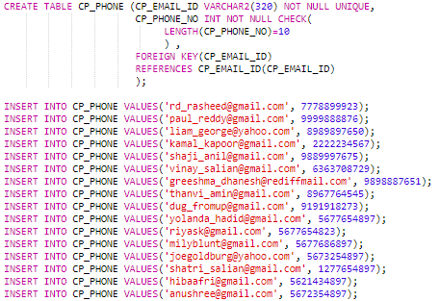

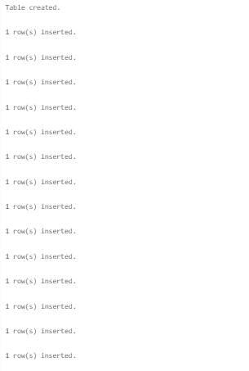

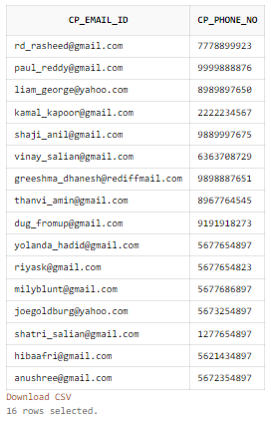

1. CP_CRIME

CREATE TABLE CP_CRIME (CP_EMAIL_ID VARCHAR2(320) NOT NULL,

CP_CRIME_RECORD VARCHAR2(250) NOT

NULL,

CP_PENALTY_DATE_TIME TIMESTAMP DEFAULT

CURRENT_TIMESTAMP NOT NULL,

FOREIGN KEY(CP_EMAIL_ID)

REFERENCES CP_EMAIL_ID(CP_EMAIL_ID),

FOREIGN KEY(CP_CRIME_RECORD)

REFERENCES CRIME_DETAILS(PEN_CRIME_COMMITTED)

);

INSERT INTO CP_CRIME(CP_EMAIL_ID, CP_CRIME_RECORD) VALUES('rd_rasheed@gmail.com', 'NO HELMET');

INSERT INTO CP_CRIME(CP_EMAIL_ID, CP_CRIME_RECORD) VALUES('paul_reddy@gmail.com', 'ROBBERY' );

INSERT INTO CP_CRIME(CP_EMAIL_ID, CP_CRIME_RECORD) VALUES('liam_george@yahoo.com', 'NO HELMET');

INSERT INTO CP_CRIME(CP_EMAIL_ID, CP_CRIME_RECORD) VALUES('kamal_kapoor@gmail.com', 'ROBBERY');

INSERT INTO CP_CRIME(CP_EMAIL_ID, CP_CRIME_RECORD) VALUES('shaji_anil@gmail.com', 'NO SEAT BELT');

INSERT INTO CP_CRIME(CP_EMAIL_ID, CP_CRIME_RECORD) VALUES('vinay_salian@gmail.com', 'FRAUD');

INSERT INTO CP_CRIME(CP_EMAIL_ID, CP_CRIME_RECORD) VALUES('greeshma_dhanesh@rediffmail.com', 'NO HELMET');

INSERT INTO CP_CRIME(CP_EMAIL_ID, CP_CRIME_RECORD) VALUES('thanvi_amin@gmail.com', 'SHOPLIFTING');

INSERT INTO CP_CRIME(CP_EMAIL_ID, CP_CRIME_RECORD) VALUES('dug_fromup@gmail.com', 'FRAUD');

INSERT INTO CP_CRIME(CP_EMAIL_ID, CP_CRIME_RECORD) VALUES('yolanda_hadid@gmail.com', 'ROBBERY');

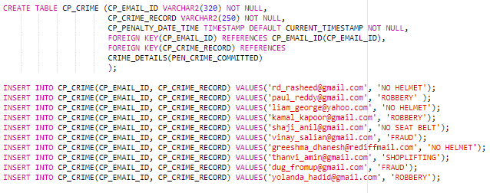



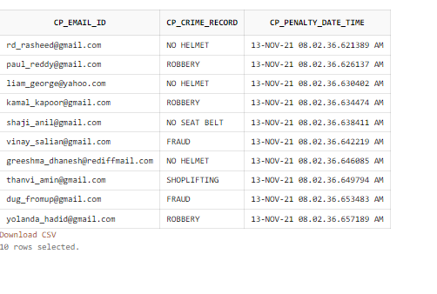

1. CP_HEALTH_ISSUES

CREATE TABLE CP_HEALTH_ISSUES (MED_EMAIL_ID VARCHAR2(320) NOT NULL,

MED_HEALTH_ISSUES VARCHAR2(50) NOT NULL,

FOREIGN KEY(MED_EMAIL_ID)

REFERENCES CP_EMAIL_ID(CP_EMAIL_ID)

);

INSERT INTO CP_HEALTH_ISSUES VALUES('rd_rasheed@gmail.com', 'LOW BLOOD PRESSURE');

INSERT INTO CP_HEALTH_ISSUES VALUES('paul_reddy@gmail.com', 'DIABETIC');

INSERT INTO CP_HEALTH_ISSUES VALUES('liam_george@yahoo.com', 'HIGH BLOOD PRESSURE');

INSERT INTO CP_HEALTH_ISSUES VALUES('kamal_kapoor@gmail.com', 'NON');

INSERT INTO CP_HEALTH_ISSUES VALUES('shaji_anil@gmail.com', 'OBESITY');

INSERT INTO CP_HEALTH_ISSUES VALUES('vinay_salian@gmail.com', 'NON');

INSERT INTO CP_HEALTH_ISSUES VALUES('greeshma_dhanesh@rediffmail.com', 'DIABETIC');

INSERT INTO CP_HEALTH_ISSUES VALUES('thanvi_amin@gmail.com', 'CONSTIPATION');

INSERT INTO CP_HEALTH_ISSUES VALUES('dug_fromup@gmail.com', 'EATING DISORDER');

INSERT INTO CP_HEALTH_ISSUES VALUES('yolanda_hadid@gmail.com', 'DIABETICS');

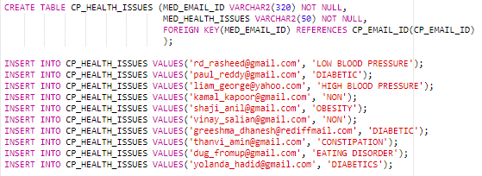



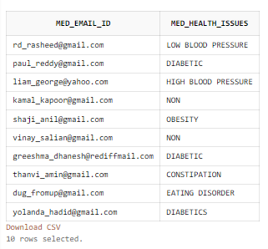

1. CP_ALLERGIES

CREATE TABLE CP_ALLERGIES (MED_EMAIL_ID VARCHAR2(320) NOT NULL,

MED_ALLERGIES VARCHAR2(50) NOT NULL,

FOREIGN KEY(MED_EMAIL_ID)

REFERENCES CP_EMAIL_ID(CP_EMAIL_ID)

);

INSERT INTO CP_ALLERGIES VALUES('rd_rasheed@gmail.com', 'ALLERGY TO PEANUT BUTTER');

INSERT INTO CP_ALLERGIES VALUES('paul_reddy@gmail.com', 'SKIN ALLERGY');

INSERT INTO CP_ALLERGIES VALUES('liam_george@yahoo.com', 'ALLERGY TO MILK');

INSERT INTO CP_ALLERGIES VALUES('kamal_kapoor@gmail.com', 'NON');

INSERT INTO CP_ALLERGIES VALUES('shaji_anil@gmail.com', 'ALLERGY TO BREAD');

INSERT INTO CP_ALLERGIES VALUES('vinay_salian@gmail.com', 'NON');

INSERT INTO CP_ALLERGIES VALUES('greeshma_dhanesh@rediffmail.com', 'ALERGY TO CHOCLATE');

INSERT INTO CP_ALLERGIES VALUES('thanvi_amin@gmail.com', 'ALLERGY TO NUTS');

INSERT INTO CP_ALLERGIES VALUES('dug_fromup@gmail.com', 'NON');

INSERT INTO CP_ALLERGIES VALUES('yolanda_hadid@gmail.com', 'NON');

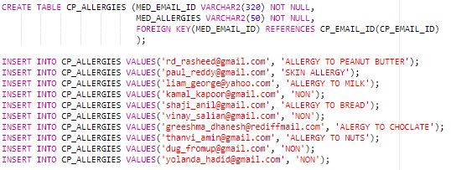



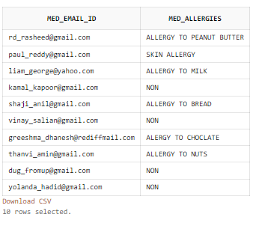

1. CP_EMERGENCY

CREATE TABLE CP_EMERGENCY_NO (MED_EMAIL_ID VARCHAR2(320) NOT NULL,

MED_EMERGENCY_NO INT NOT NULL CHECK (

LENGTH(MED_EMERGENCY_NO)=10

),

FOREIGN KEY(MED_EMAIL_ID)

REFERENCES CP_EMAIL_ID(CP_EMAIL_ID)

);

INSERT INTO CP_EMERGENCY_NO VALUES('rd_rasheed@gmail.com', 9822338809);

INSERT INTO CP_EMERGENCY_NO VALUES('paul_reddy@gmail.com', 6787992211);

INSERT INTO CP_EMERGENCY_NO VALUES('liam_george@yahoo.com', 9090876212);

INSERT INTO CP_EMERGENCY_NO VALUES('kamal_kapoor@gmail.com', 5678341288);

INSERT INTO CP_EMERGENCY_NO VALUES('shaji_anil@gmail.com', 4599998745);

INSERT INTO CP_EMERGENCY_NO VALUES('vinay_salian@gmail.com', 6238862733);

INSERT INTO CP_EMERGENCY_NO VALUES('greeshma_dhanesh@rediffmail.com', 6677982389);

INSERT INTO CP_EMERGENCY_NO VALUES('thanvi_amin@gmail.com', 9847110358);

INSERT INTO CP_EMERGENCY_NO VALUES('dug_fromup@gmail.com', 9878964444);

INSERT INTO CP_EMERGENCY_NO VALUES('yolanda_hadid@gmail.com', 7898673654);

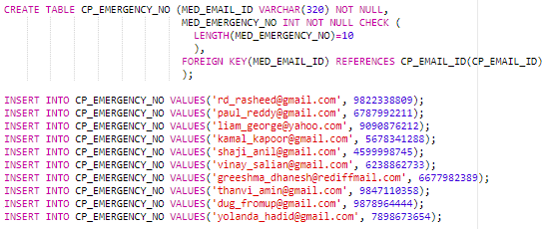



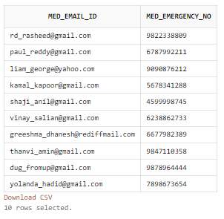

1. MMED_HEALTH_ISSUES

CREATE TABLE MMED_HEALTH_ISSUES (MMED_MINOR_ID INT NOT NULL,

MMED_HEALTH_ISSUES VARCHAR2(50) NOT NULL,

FOREIGN KEY(MMED_MINOR_ID)

REFERENCES USER_ID_MINOR(ID)

);

INSERT INTO MMED_HEALTH_ISSUES VALUES(1, 'NON');

INSERT INTO MMED_HEALTH_ISSUES VALUES(2,'ANEMIA');

INSERT INTO MMED_HEALTH_ISSUES VALUES(3, 'DYSLIPIDEAMIA');

INSERT INTO MMED_HEALTH_ISSUES VALUES(4, 'HEART PATIENT');

INSERT INTO MMED_HEALTH_ISSUES VALUES(5, 'NON');

INSERT INTO MMED_HEALTH_ISSUES VALUES(6, 'NON');

INSERT INTO MMED_HEALTH_ISSUES VALUES(7, 'DIABETICS');

INSERT INTO MMED_HEALTH_ISSUES VALUES(8, 'OBESITY');

INSERT INTO MMED_HEALTH_ISSUES VALUES(9, 'NON');

INSERT INTO MMED_HEALTH_ISSUES VALUES(10, 'NON');

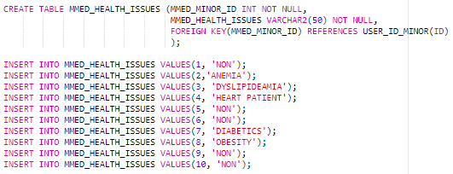



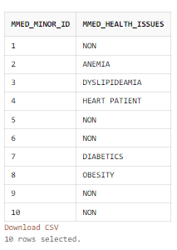

1. MMED_ALLERGIES

CREATE TABLE MMED_ALLERGIES (MMED_MINOR_ID INT NOT NULL ,

MMED_ALLERGIES VARCHAR2(50) NOT NULL,

FOREIGN KEY(MMED_MINOR_ID)

REFERENCES USER_ID_MINOR(ID)

);

INSERT INTO MMED_ALLERGIES VALUES(1,'ALLERGY TO PEANUTS');

INSERT INTO MMED_ALLERGIES VALUES(2, 'ALLERGY TO LACTINE');

INSERT INTO MMED_ALLERGIES VALUES(3, 'ALLERGY TO LEMON');

INSERT INTO MMED_ALLERGIES VALUES(4, 'ALLERGY TO GARLIC');

INSERT INTO MMED_ALLERGIES VALUES(5, 'NON');

INSERT INTO MMED_ALLERGIES VALUES(6, 'NON');

INSERT INTO MMED_ALLERGIES VALUES(7, 'ALLERGY TO CHOCLATES');

INSERT INTO MMED_ALLERGIES VALUES(8, 'NON');

INSERT INTO MMED_ALLERGIES VALUES(9, 'NON');

INSERT INTO MMED_ALLERGIES VALUES(10, 'ALLERGY TO DOGS');

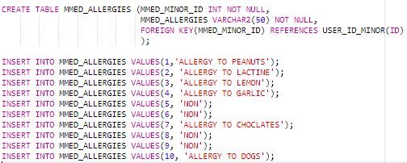



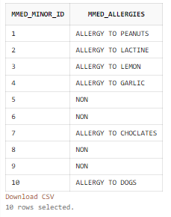

1. DC_DETAILS

CREATE TABLE DC_DETAILS (ID INTEGER GENERATED BY DEFAULT ON NULL AS IDENTITY,

DC_EMAIL_ID VARCHAR2(320) NOT NULL,

DC_PATIENT_ID VARCHAR2(50) ,

DC_LOCATION VARCHAR2(1000) NOT NULL,

DC_DOC_NAME VARCHAR2(50) NOT NULL,

DC_DATE_TIME TIMESTAMP DEFAULT CURRENT_TIMESTAMP NOT NULL,

DC_PATIENT_STATUS VARCHAR2(10) NOT NULL,

DC_CALL_REASON VARCHAR2(50) NOT NULL,

PRIMARY KEY(ID),

FOREIGN KEY(DC_EMAIL_ID)

REFERENCES D_EMAIL_ID(D_EMAIL_ID)

);

CREATE OR REPLACE TRIGGER PATIENT_ID

AFTER INSERT ON DC_DETAILS

BEGIN

UPDATE DC_DETAILS SET DC_PATIENT_ID = CONCAT('PAT',ID);

END;

/

INSERT INTO DC_DETAILS(ID, DC_EMAIL_ID, DC_LOCATION, DC_DOC_NAME, DC_PATIENT_STATUS, DC_CALL_REASON) VALUES(1, 'hibaafri@gmail.com', 'MG ROAD BHANDRA MAHARASHTRA', 'HIBA AFRI', 'STABLE', 'CAR ACCIDENT' );

INSERT INTO DC_DETAILS(ID, DC_EMAIL_ID, DC_LOCATION, DC_DOC_NAME, DC_PATIENT_STATUS, DC_CALL_REASON) VALUES(2, 'pratheeksha@gmail.com', 'BC ROAD BHANDRAN MAHARASHTRA', 'PRATHEEKSHA S', 'CRITICAL', 'FIRE ACCIDENT' );

INSERT INTO DC_DETAILS(ID, DC_EMAIL_ID, DC_LOCATION, DC_DOC_NAME, DC_PATIENT_STATUS, DC_CALL_REASON) VALUES(3, 'anushree@gmail.com', 'MODI ROAD DELHI', 'ANU SHREE', 'MODERATE', 'FAINTED');

INSERT INTO DC_DETAILS(ID, DC_EMAIL_ID, DC_LOCATION, DC_DOC_NAME, DC_PATIENT_STATUS, DC_CALL_REASON) VALUES(4, 'anurag@gmail.com', 'HILLY HILL MYSORE KARNATAKA', 'ANURAG KASHYAP', 'STABLE', 'CAR ACCIDENT');

INSERT INTO DC_DETAILS(ID, DC_EMAIL_ID, DC_LOCATION, DC_DOC_NAME, DC_PATIENT_STATUS, DC_CALL_REASON) VALUES(5, 'robinhood@gmail.com', 'MIMI SCHOOL COIMBATORE TAMIL NADU', 'ROBIN PAUL', 'CRITICAL', 'BLOOD PRESSURE');

INSERT INTO DC_DETAILS(ID, DC_EMAIL_ID, DC_LOCATION, DC_DOC_NAME, DC_PATIENT_STATUS, DC_CALL_REASON) VALUES(6, 'mariyam@gmail.com', 'GIGI ROAD KOLKATA WEST BENGAL', 'MARIYAM THAHIRA', 'CRITICAL', 'CAR ACCIDENT');

INSERT INTO DC_DETAILS(ID, DC_EMAIL_ID, DC_LOCATION, DC_DOC_NAME, DC_PATIENT_STATUS, DC_CALL_REASON) VALUES(7, 'poorvi@gmail.com', 'ZAYN ROAD KOLKATA WEST BENGAL', 'POORVI MOHAN', 'CRITICAL', 'CARDIAC ARREST');

INSERT INTO DC_DETAILS(ID, DC_EMAIL_ID, DC_LOCATION, DC_DOC_NAME, DC_PATIENT_STATUS, DC_CALL_REASON) VALUES(8, 'farzin@gmail.com', 'GHAZA ROAD MANGLORE KARNATAKA', 'FARZIN MOHAMMED', 'MODERATE', 'CAR ACCIDENT');

INSERT INTO DC_DETAILS(ID, DC_EMAIL_ID, DC_LOCATION, DC_DOC_NAME, DC_PATIENT_STATUS, DC_CALL_REASON) VALUES(9, 'souhanabbas@gmail.com', 'BC ROAD CHENNAI TAMIL NADU', 'SOUHAN ABBAS', 'STABLE', 'FIRE ACCIDENT');

INSERT INTO DC_DETAILS(ID, DC_EMAIL_ID, DC_LOCATION, DC_DOC_NAME, DC_PATIENT_STATUS, DC_CALL_REASON) VALUES(10, 'afreedi@gmail.com', 'HALLO STREET BENGLORE KARNATAKA', 'AFREEDI SK', 'CRITICAL', 'STROKE');

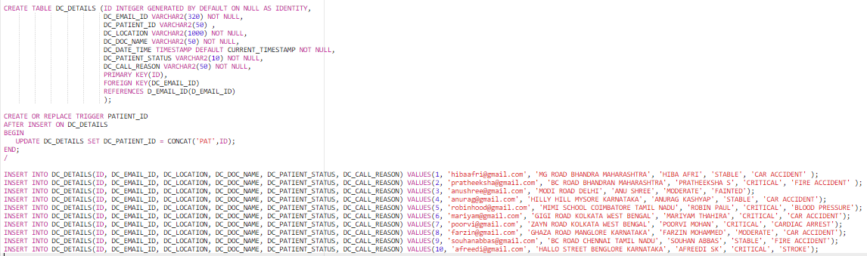

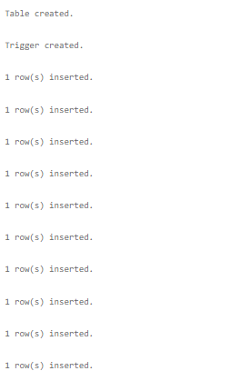

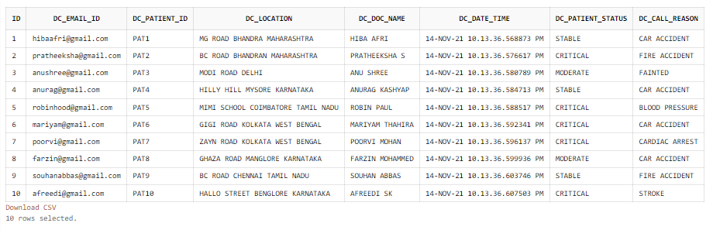

1. DC_PATIENT_DETAIL

CREATE TABLE DC_PATIENT_DETAIL (DC_PATIENT_ID INT NOT NULL,

DC_PATIENT_DETAIL VARCHAR2(50) NOT NULL,

FOREIGN KEY(DC_PATIENT_ID)

REFERENCES DC_DETAILS(ID)

);

INSERT INTO DC_PATIENT_DETAIL VALUES(1, 'LIAM GEORGE');

INSERT INTO DC_PATIENT_DETAIL VALUES(2, 'RASHEED R D');

INSERT INTO DC_PATIENT_DETAIL VALUES(3, 'KAMAL KAPOOR');

INSERT INTO DC_PATIENT_DETAIL VALUES(4, 'YOLANDA HADID');

INSERT INTO DC_PATIENT_DETAIL VALUES(5, 'THANVI AMIN');

INSERT INTO DC_PATIENT_DETAIL VALUES(6, 'GREESHMA DHANESH');

INSERT INTO DC_PATIENT_DETAIL VALUES(7, 'KAMAL KAPOOR');

INSERT INTO DC_PATIENT_DETAIL VALUES(8,'SHAJI ANIL');

INSERT INTO DC_PATIENT_DETAIL VALUES(9, 'PAUL REDDY');

INSERT INTO DC_PATIENT_DETAIL VALUES(10, 'VINAY SALIAN');

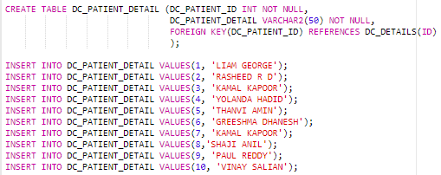



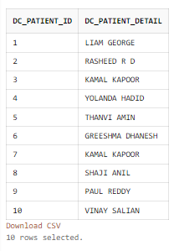

1. DC_PROCEDURE

CREATE TABLE DC_PROCEDURE (DC_PATIENT_ID INT NOT NULL,

DC_PROCEDURE_DONE VARCHAR2(50) NOT NULL,

FOREIGN KEY(DC_PATIENT_ID)

REFERENCES DC_DETAILS(ID)

);

INSERT INTO DC_PROCEDURE VALUES(1, 'MEDICINS');

INSERT INTO DC_PROCEDURE VALUES(2, 'MINOR OPERATION');

INSERT INTO DC_PROCEDURE VALUES(3, 'THERAPIES');

INSERT INTO DC_PROCEDURE VALUES(4, 'MAJOR SURGERIES');

INSERT INTO DC_PROCEDURE VALUES(5, 'MEDICINES');

INSERT INTO DC_PROCEDURE VALUES(6, 'FIRST AID');

INSERT INTO DC_PROCEDURE VALUES(7, 'INJECTIONS');

INSERT INTO DC_PROCEDURE VALUES(8, 'MAJOR OPERATION');

INSERT INTO DC_PROCEDURE VALUES(9, 'FIRST AID');

INSERT INTO DC_PROCEDURE VALUES(10, 'INJECTIONS');

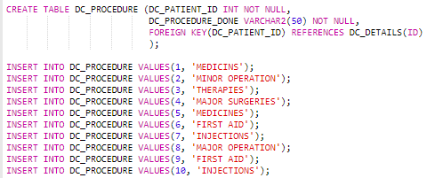



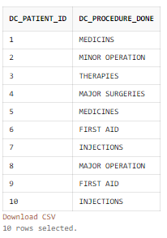

1. P_LICENSE

CREATE TABLE P_LICENSE (PL_LICENSE_NO VARCHAR2(320),

PL_ISSUED_DATE DATE NOT NULL,

CONSTRAINT PK_PL_LICENSE_NO

PRIMARY KEY (PL_LICENSE_NO)

);

INSERT INTO P_LICENSE VALUES('AA3434', to_date('12-10-1998','dd-mm-yyyy'));

INSERT INTO P_LICENSE VALUES('AB4455', to_date('11-05-2001','dd-mm-yyyy'));

INSERT INTO P_LICENSE VALUES('DD4545', to_date('12-09-2002','dd-mm-yyyy'));

INSERT INTO P_LICENSE VALUES('GH6789', to_date('02-07-2008','dd-mm-yyyy'));

INSERT INTO P_LICENSE VALUES('SJ2343', to_date('10-03-1998','dd-mm-yyyy'));

INSERT INTO P_LICENSE VALUES('JJ8756', to_date('03-04-2009','dd-mm-yyyy'));

INSERT INTO P_LICENSE VALUES('HJ3456', to_date('14-07-2007','dd-mm-yyyy'));

INSERT INTO P_LICENSE VALUES('DD8989', to_date('12-09-1999','dd-mm-yyyy'));

INSERT INTO P_LICENSE VALUES('TT3476', to_date('17-06-2005','dd-mm-yyyy'));

INSERT INTO P_LICENSE VALUES('RR4398', to_date('12-09-1998','dd-mm-yyyy')); 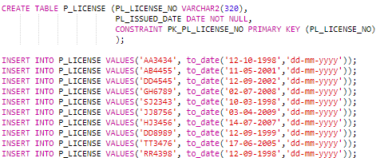



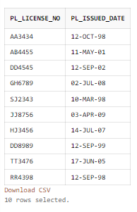

1. P_LICENSENO

CREATE TABLE P_LICENSENO (P_EMAIL_ID VARCHAR2(320) UNIQUE NOT NULL,

P_LICENSE_NO VARCHAR2(50) UNIQUE ,

FOREIGN KEY(P_EMAIL_ID)

REFERENCES P_EMAIL_ID(P_EMAIL_ID),

FOREIGN KEY(P_LICENSE_NO)

REFERENCES P_LICENSE(PL_LICENSE_NO)

);

INSERT INTO P_LICENSENO VALUES('riyask@gmail.com', 'AA3434');

INSERT INTO P_LICENSENO VALUES('milyblunt@gmail.com', 'AB4455');

INSERT INTO P_LICENSENO VALUES('joegoldburg@yahoo.com', 'DD4545' );

INSERT INTO P_LICENSENO VALUES('shatri_salian@gmail.com', 'GH6789');

INSERT INTO P_LICENSENO VALUES('lakshmi_kp@gmail.com', 'SJ2343');

INSERT INTO P_LICENSENO VALUES('athira_ar@rediff.com', 'JJ8756' );

INSERT INTO P_LICENSENO VALUES('kendal_jenner@gmail.com', 'HJ3456');

INSERT INTO P_LICENSENO VALUES('kylie_jenner@gmail.com', 'DD8989');

INSERT INTO P_LICENSENO VALUES('travis_scott@gmail.com', 'TT3476');

INSERT INTO P_LICENSENO VALUES('chris_evans@gmail.com', 'RR4398');

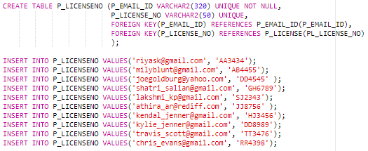



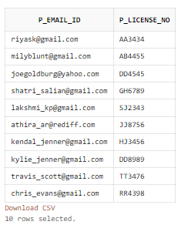

1. P_LOGIN

CREATE TABLE P_LOGIN (P_LOGIN_ID VARCHAR(320) NOT NULL,

P_DATE_TIME TIMESTAMP DEFAULT CURRENT_TIMESTAMP NOT

NULL,

CONSTRAINT PK_P_LOGIN

PRIMARY KEY (P_LOGIN_ID,P_DATE_TIME),

FOREIGN KEY(P_LOGIN_ID)

REFERENCES P_EMAIL_ID(P_EMAIL_ID)

);

INSERT INTO P_LOGIN(P_LOGIN_ID)VALUES('riyask@gmail.com');

INSERT INTO P_LOGIN(P_LOGIN_ID)VALUES('milyblunt@gmail.com');

INSERT INTO P_LOGIN(P_LOGIN_ID)VALUES('joegoldburg@yahoo.com');

INSERT INTO P_LOGIN(P_LOGIN_ID)VALUES('shatri_salian@gmail.com');

INSERT INTO P_LOGIN(P_LOGIN_ID)VALUES('lakshmi_kp@gmail.com');

INSERT INTO P_LOGIN(P_LOGIN_ID)VALUES('athira_ar@rediff.com');

INSERT INTO P_LOGIN(P_LOGIN_ID)VALUES('kendal_jenner@gmail.com');

INSERT INTO P_LOGIN(P_LOGIN_ID)VALUES('kylie_jenner@gmail.com');

INSERT INTO P_LOGIN(P_LOGIN_ID)VALUES('travis_scott@gmail.com');

INSERT INTO P_LOGIN(P_LOGIN_ID)VALUES('chris_evans@gmail.com');

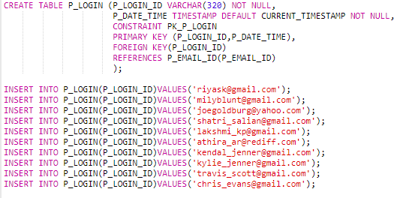

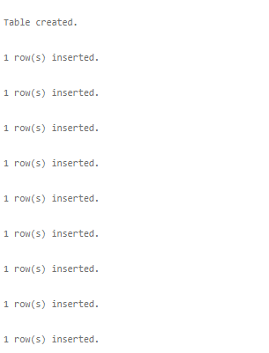

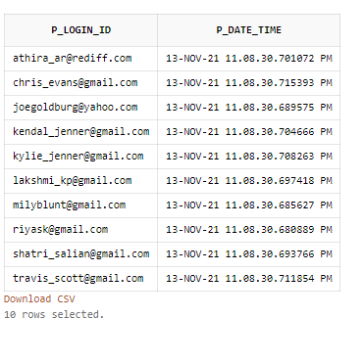

1. P_DETAILS

CREATE TABLE P_DETAILS (P_EMAIL_ID VARCHAR2(50) NOT NULL,

P_QUALIFICATION VARCHAR2(50) NOT NULL,

P_DESIGNATION VARCHAR2(50) NOT NULL,

P_EXPERIENCE INT NOT NULL,

P_BRANCH VARCHAR2(30) NOT NULL,

FOREIGN KEY(P_EMAIL_ID)

REFERENCES P_EMAIL_ID(P_EMAIL_ID)

);

CREATE UNIQUE INDEX I_P_DETAILS ON P_DETAILS(P_EMAIL_ID);

INSERT INTO P_DETAILS VALUES('riyask@gmail.com', 'BACHELORS DEGREE', 'DIRECTOR OF GENERAL', 3, 'HIGHWAY POLICE');

INSERT INTO P_DETAILS VALUES('milyblunt@gmail.com', 'BACHELORS DEGREE', 'CIRCLE INSPECTOR', 7, 'UNIFORMED OFFICERS' );

INSERT INTO P_DETAILS VALUES('joegoldburg@yahoo.com', 'BACHELORS DEGREE', 'SP', 5, 'STATE POLICE');

INSERT INTO P_DETAILS VALUES('shatri_salian@gmail.com', 'CRIMINAL JUSTICE', 'SHERIFFS', 7, 'UNIFORMED OFFICERS');

INSERT INTO P_DETAILS VALUES('lakshmi_kp@gmail.com', 'CYBER SECURITY', 'INSPECTOR GENERAL', 8, 'DETECTIVES');

INSERT INTO P_DETAILS VALUES('athira_ar@rediff.com', 'CRIMINAL JUSTICE', 'SENIOR SUPERINDENT', 7, 'STATE POLICE');

INSERT INTO P_DETAILS VALUES('kendal_jenner@gmail.com', 'BACHELOR DEGREE', 'CORPORAL', 9, 'HIGHWAY POLICE');

INSERT INTO P_DETAILS VALUES('kylie_jenner@gmail.com', 'BACHELORS DEGREE', 'INSPECTOR GENERAL', 7, 'HIGHWAY POLICE');

INSERT INTO P_DETAILS VALUES('travis_scott@gmail.com', 'CRIMINAL JUSTICE', 'SHERIIFS', 8, 'STATE POLICE');

INSERT INTO P_DETAILS VALUES('chris_evans@gmail.com', 'CYBER SECURITY', 'CIRCLE INSPECTOR', 9, 'DETECTIVES');

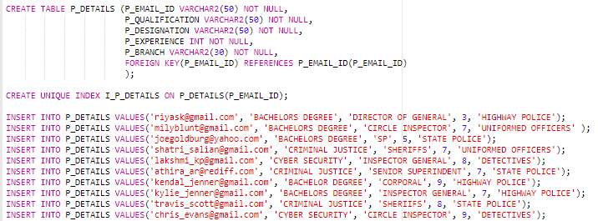

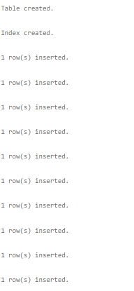

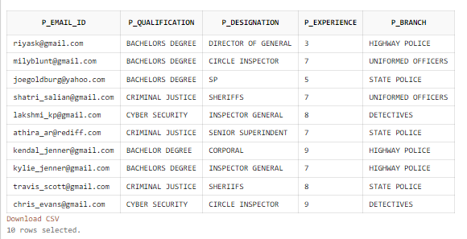

* **SIMPLE QUERIES:**
* **UPDATE THE PENALITY STATUS OF THE USER WITH EMAIL ID 'shaji_anil@gmail.com', 'greeshma_dhanesh@rediffmail.com' TO 'YES'**

UPDATE C_PENALITY SET PEN_PAID_OR_NOT = 'YES' WHERE PEN_CP_EMAIL_ID = 'shaji_anil@gmail.com' OR PEN_CP_EMAIL_ID = 'greeshma_dhanesh@rediffmail.com';

SELECT * FROM C_PENALITY;



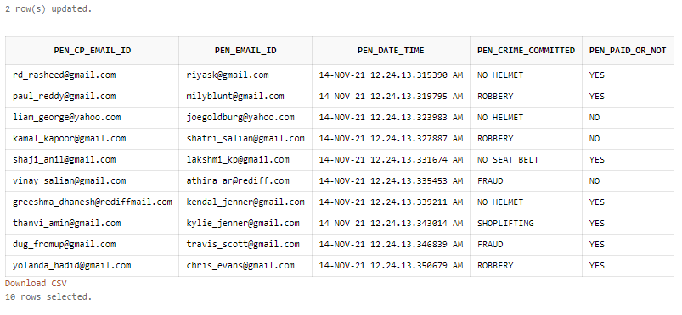

* **DISPLAY THE DETAILS OF THE USERS IN INCREASING ORDER OF THEIR TOTAL PENALITY**

SELECT CP_EMAIL_ID, CP_NAME, CP_GENDER, CP_AGE, CP_ADDRESS, CP_TOTAL_PENALTY FROM CP_DETAILS ORDER BY CP_TOTAL_PENALTY DESC;



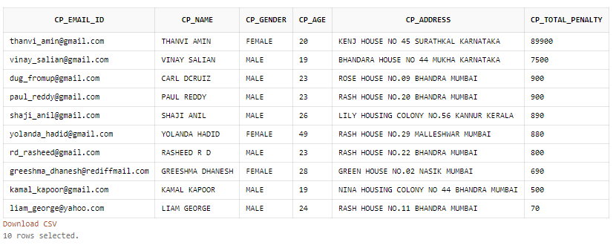

* **DISPLAY THE VEHICLE DETAILS OF VEHICLES THAT BELONG TO 'KARNATAKA' AND 'TAMIL NADU'**

SELECT V_VEHICLE_NO, V_VEHICLE_TYPE, V_VEHICLE_NAME FROM VEHICLE_DETAILS WHERE V_VEHICLE_NO LIKE 'KA%' OR V_VEHICLE_NO LIKE 'TN%';



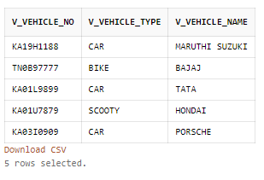

* **DISPLAY THE DETAILS OF THE USERS WHO HAVE A CRIME RECORD AS 'NO HELMET'**

SELECT C_PENALITY.PEN_CP_EMAIL_ID, CP_DETAILS.CP_NAME, C_PENALITY.PEN_EMAIL_ID, C_PENALITY.PEN_PAID_OR_NOT FROM C_PENALITY,CP_DETAILS WHERE CP_DETAILS.CP_EMAIL_ID = C_PENALITY.PEN_CP_EMAIL_ID AND PEN_CRIME_COMMITTED IN (SELECT PEN_CRIME_COMMITTED FROM C_PENALITY WHERE PEN_CRIME_COMMITTED = 'NO HELMET');



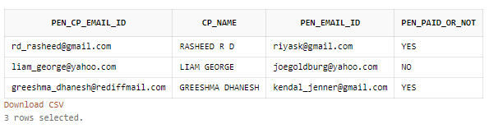

* **DISPLAY THE LICENSE DETAILS OF THE DOCTORS WHOSE LICENSE WAS ISSUED AFTER 12TH SEPTEMBER, 2002**

SELECT P_LICENSE.PL_LICENSE_NO,P_LICENSE.PL_ISSUED_DATE FROM P_LICENSE WHERE PL_ISSUED_DATE > TO_DATE('12-09-2002','DD-MM-YYYY');



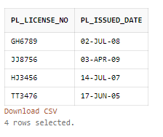

* **AGGREGATE:**
* AVG

**DISPLAY THE NAME, EMAIL ID AND TOTAL PENALITY OF THE USERS WHOSE TOTAL PENALITY IS LESS THAN THE AVERAGE OF TOTAL PENALITY.**

SELECT CP_EMAIL_ID,CP_NAME,CP_TOTAL_PENALTY FROM CP_DETAILS WHERE CP_TOTAL_PENALTY < (SELECT AVG(CP_TOTAL_PENALTY) FROM CP_DETAILS);



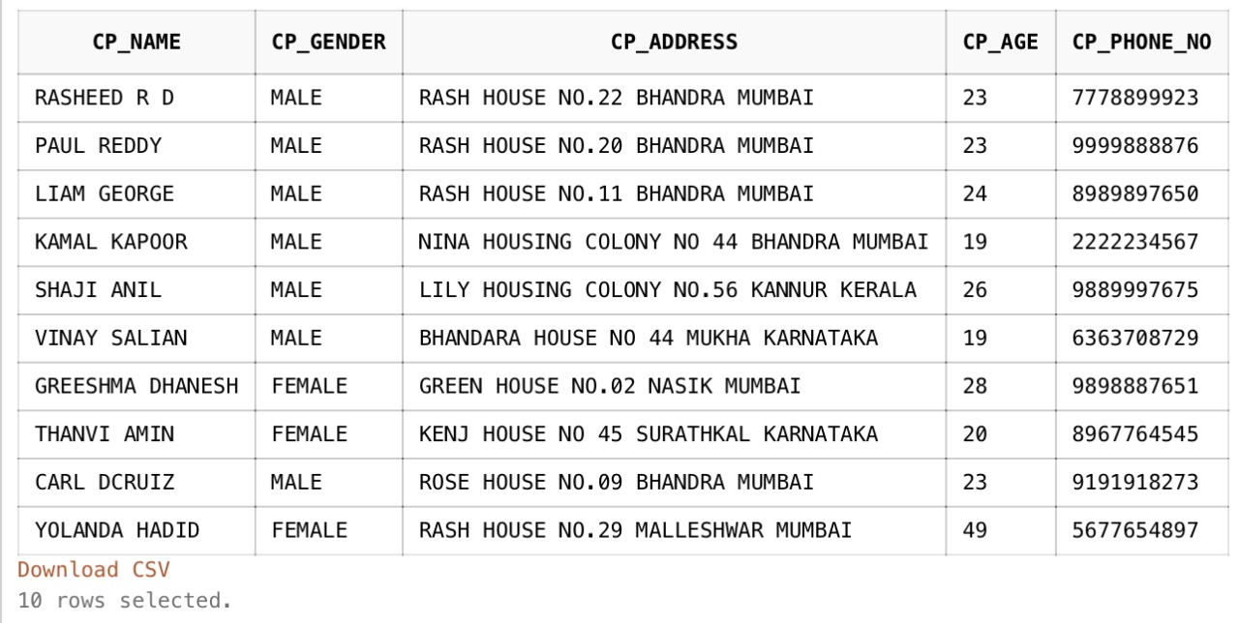

* MAX

**DISPLAY THE DETAILS OF POLICE OFFICERS WHOSE EXPERIENCE IS LESSER THAN THE MAXIMUM EXPERIENCE OF POLICE OFFICERS**

SELECT P_EMAIL_ID,P_EXPERIENCE,P_DESIGNATION FROM P_DETAILS WHERE P_EXPERIENCE < (SELECT MAX(P_EXPERIENCE) FROM P_DETAILS);



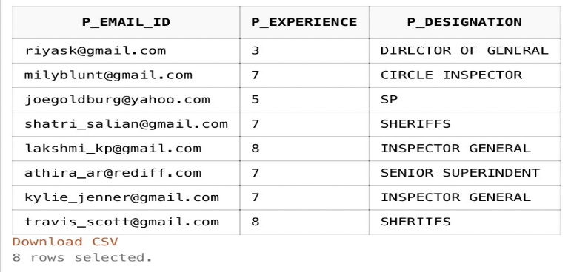

* COUNT

**DISPLAY THE NUMBER OF PEOPLE WHO ARE AFFECTED BY EACH CALL REASON.**

SELECT DC_CALL_REASON, COUNT(*) AS COUNT_CALL_REASON FROM DC_DETAILS GROUP BY DC_CALL_REASON;



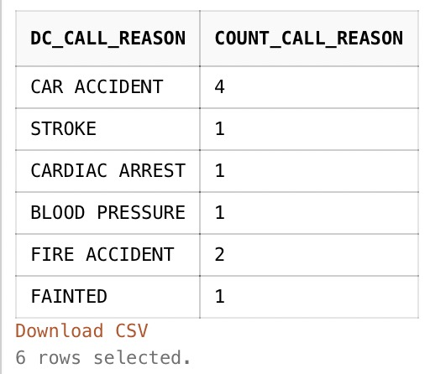

* MIN

**DISPLAY THE NAME, GENDER AND AGE OF THE MINORS WHOSE AGE IS GREATER THAN THE MINIMUM MINOR AGE.**

SELECT MIN_NAME, MIN_GENDER, MIN_AGE FROM MINOR_DETAILS WHERE MIN_AGE > (SELECT MIN(MIN_AGE) FROM MINOR_DETAILS);



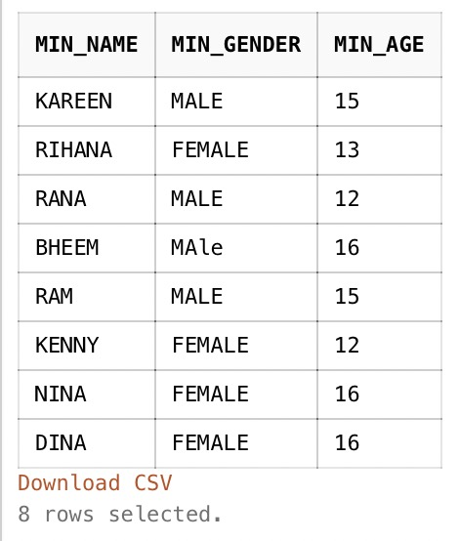

* SUM

**DISPLAY THE SUM OF PENALTY THAT IS PAID FOR EACH CRIME COMMITTED.**

SELECT C_PENALITY.PEN_CRIME_COMMITTED, SUM(CRIME_DETAILS.PEN_PENALITY) AS PAID_PENALITY,C_PENALITY.PEN_PAID_OR_NOT FROM C_PENALITY, CRIME_DETAILS

WHERE C_PENALITY.PEN_CRIME_COMMITTED = CRIME_DETAILS.PEN_CRIME_COMMITTED AND C_PENALITY.PEN_PAID_OR_NOT ='YES' GROUP BY C_PENALITY.PEN_CRIME_COMMITTED, C_PENALITY.PEN_PAID_OR_NOT;



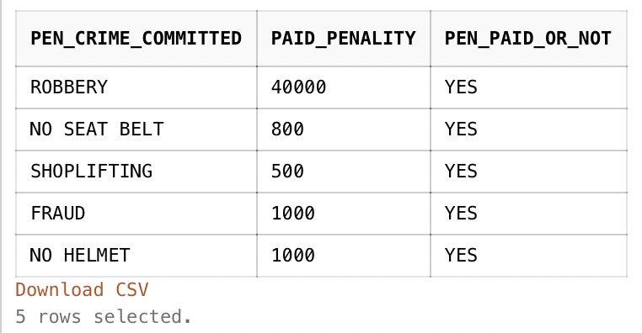

* **JOIN:**
* INNER JOIN

**DISPLAY THE PERSONAL AND MEDICAL DETAILS OF THE USERS FROM CP_DETAILS, CP_HEALTH_ISSUES AND CP_ALLERGIES TABLE USING INNER JOIN.**

SELECT CP_DETAILS.CP_EMAIL_ID, CP_DETAILS.CP_NAME, CP_DETAILS.CP_AGE, CP_DETAILS.MED_HEIGHT, CP_DETAILS.MED_WEIGHT, CP_DETAILS.MED_BLOOD_GROUP, CP_HEALTH_ISSUES.MED_HEALTH_ISSUES, CP_ALLERGIES.MED_ALLERGIES FROM CP_DETAILS INNER JOIN CP_HEALTH_ISSUES ON CP_DETAILS.CP_EMAIL_ID = CP_HEALTH_ISSUES.MED_EMAIL_ID INNER JOIN CP_ALLERGIES ON CP_DETAILS.CP_EMAIL_ID = CP_ALLERGIES.MED_EMAIL_ID;



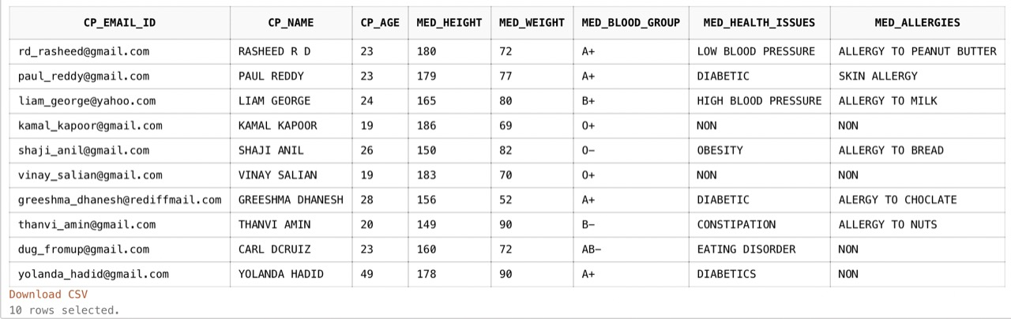

* LEFT JOIN

**DISPLAY THE DOCTOR LICENSE DETAILS AND DOCTOR DETAILS FROM D_LICENSE, D_DETAILS AND D_LICENSENO TABLE USING LEFT JOIN.**

SELECT D_DETAILS.D_EMAIL_ID, D_LICENSENO.D_LICENSE_ID, D_LICENSE.DL_ISSUED_DATE, D_DETAILS.D_HOSPITAL_NAME, D_DETAILS.D_QUALIFICATION, D_DETAILS.D_EXPERIENCE, D_DETAILS.D_SPECIALITY FROM D_DETAILS LEFT JOIN D_LICENSENO ON D_DETAILS.D_EMAIL_ID = D_LICENSENO.D_EMAIL_ID LEFT JOIN D_LICENSE ON D_LICENSENO.D_LICENSE_ID = D_LICENSE.DL_LICENSE_ID;



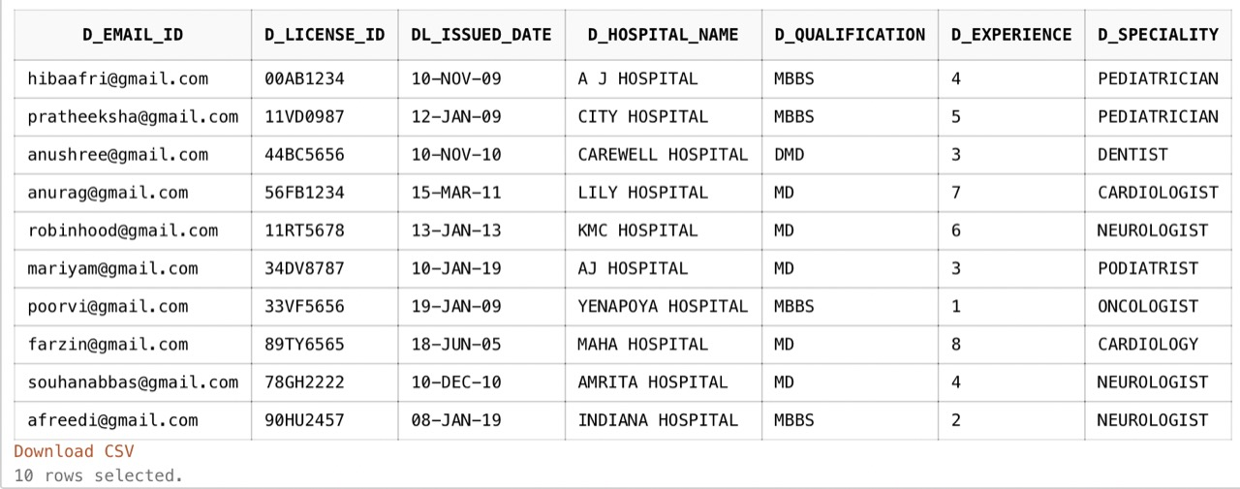

* RIGHT JOIN

**DISPLAY THE AMBULANCE AND PATIENT DETAILS FROM AMB_DETAILS, DC_DETAILS AND DC_PROCEDURE TABLE USING RIGHT JOIN.**

SELECT DC_DETAILS.DC_EMAIL_ID, DC_DETAILS.DC_PATIENT_ID, AMB_DETAILS.A_LOCATION, DC_DETAILS.DC_DOC_NAME, DC_DETAILS.DC_DATE_TIME, DC_DETAILS.DC_PATIENT_STATUS, DC_DETAILS.DC_CALL_REASON, DC_PROCEDURE.DC_PROCEDURE_DONE

FROM AMB_DETAILS RIGHT JOIN DC_DETAILS ON AMB_DETAILS.A_LOCATION = DC_DETAILS.DC_LOCATION RIGHT JOIN DC_PROCEDURE ON DC_DETAILS.ID = DC_PROCEDURE.DC_PATIENT_ID;



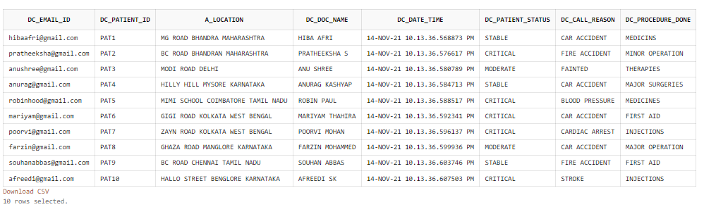

* FULL JOIN

**DISPLAY THE CRIME AND PENALITY DETAILS OF THE USERS WHO HAVE COMMITTED CRIME FROM C_PENALITY, CP_DETAILS AND CRIME_DETAILS TABLE USING FULL JOIN.**

SELECT CRIME_DETAILS.PEN_CRIME_COMMITTED, CRIME_DETAILS.PEN_PENALITY, CP_DETAILS.CP_NAME, C_PENALITY.PEN_CP_EMAIL_ID, C_PENALITY.PEN_EMAIL_ID, C_PENALITY.PEN_DATE_TIME, C_PENALITY.PEN_PAID_OR_NOT FROM C_PENALITY FULL JOIN CRIME_DETAILS ON

C_PENALITY.PEN_CRIME_COMMITTED = CRIME_DETAILS.PEN_CRIME_COMMITTED FULL JOIN CP_DETAILS ON CP_DETAILS.CP_EMAIL_ID = C_PENALITY.PEN_CP_EMAIL_ID;



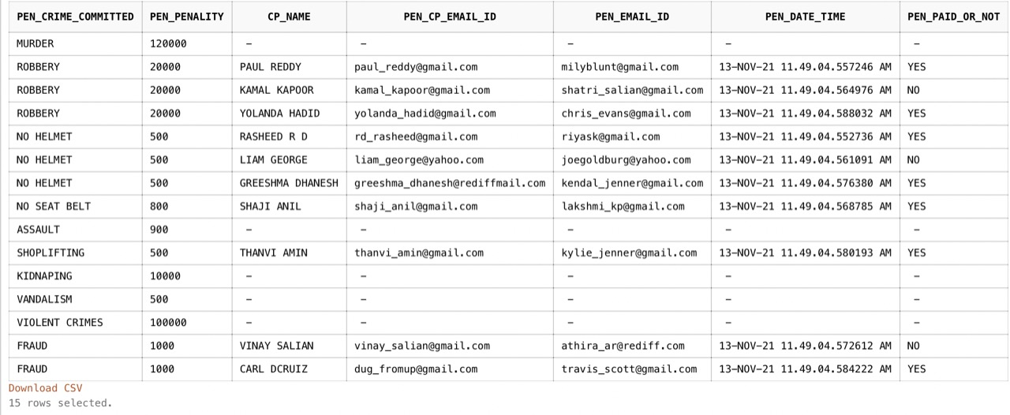

* NATURAL JOIN

**DISPLAY THE USER DETAILS ALONG WITH THEIR PHONE NUMBER FROM CP_DETAILS AND CP_PHONE TABLE USING NATURAL INNER JOIN.**

SELECT CP_DETAILS.CP_NAME, CP_DETAILS.CP_GENDER, CP_DETAILS.CP_ADDRESS, CP_DETAILS.CP_AGE, CP_PHONE.CP_PHONE_NO FROM CP_DETAILS NATURAL INNER JOIN CP_PHONE;





* **VIEW:**

**FOR EACH USER OF THE WEBSITE DIFFERENT VIEWS ARE CREATED SO AS TO PROVIDE APPROPRIATE PRIVILAGES TO USERS, DOCTOR AND POLICE. SO THAT THEY CAN UPDATE AND VIEW THEIR DETAILS FROM THE VIEWS CREATED.**

* V_POLICE_PENALITY

**CREATE A VIEW FOR THE POLICE TO VIEW AND UPDATE THE PENALITY DETAILS OF THE USERS WHO HAVE COMMITTED A CRIME.**

CREATE OR REPLACE VIEW V_POLICE_PENALITY AS SELECT CP_DETAILS.CP_NAME, CP_PHONE.CP_PHONE_NO, CP_DETAILS.CP_GENDER, CP_DETAILS.CP_AGE, CP_DETAILS.CP_ADDRESS, C_PENALITY.PEN_CP_EMAIL_ID, C_PENALITY.PEN_EMAIL_ID, C_PENALITY.PEN_CRIME_COMMITTED, CRIME_DETAILS.PEN_PENALITY, C_PENALITY.PEN_DATE_TIME, C_PENALITY.PEN_PAID_OR_NOT, CP_DETAILS.CP_TOTAL_PENALTY FROM CP_DETAILS, C_PENALITY, CP_PHONE, CRIME_DETAILS WHERE CP_DETAILS.CP_EMAIL_ID = C_PENALITY.PEN_CP_EMAIL_ID AND CP_DETAILS.CP_EMAIL_ID = CP_PHONE.CP_EMAIL_ID AND C_PENALITY.PEN_CRIME_COMMITTED = CRIME_DETAILS.PEN_CRIME_COMMITTED;

SELECT * FROM V_POLICE_PENALITY;



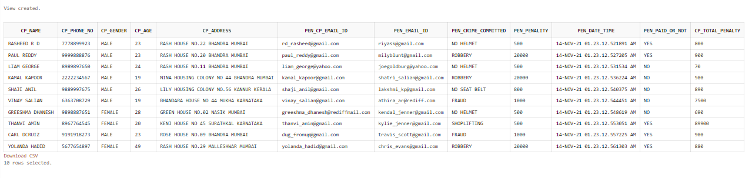

* V_USER_PENALITY

**CREATE A VIEW FOR THE USERS TO VIEW THEIR CRIME AND PENALITY DETAILS.**

CREATE OR REPLACE VIEW V_USER_PENALITY AS SELECT C_PENALITY.PEN_EMAIL_ID, CP_CRIME.CP_EMAIL_ID, CP_CRIME.CP_CRIME_RECORD, CRIME_DETAILS.PEN_PENALITY, C_PENALITY.PEN_PAID_OR_NOT

FROM C_PENALITY, CP_CRIME, CRIME_DETAILS WHERE C_PENALITY.PEN_CP_EMAIL_ID =CP_CRIME.CP_EMAIL_ID AND CP_CRIME.CP_CRIME_RECORD = CRIME_DETAILS.PEN_CRIME_COMMITTED ;

SELECT * FROM V_USER_PENALITY;



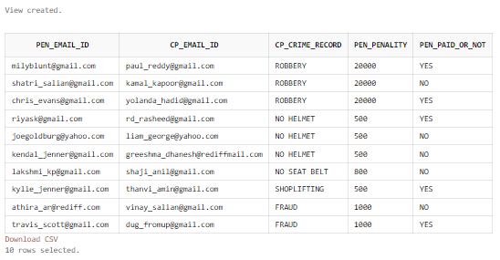

* V_POLICE_CP

**CREATE A VIEW FOR THE POLICE TO VIEW THE PERSONAL DETAILS OF THE USERS ALONG WITH THEIR VEHICLE DETAILS.**

CREATE OR REPLACE VIEW V_POLICE_CP AS SELECT CP_DETAILS.CP_EMAIL_ID, CP_DETAILS.CP_NAME, CP_DETAILS.CP_GENDER, CP_DETAILS.CP_AGE, CP_DETAILS.CP_ADDRESS,

VEHICLE_DETAILS.V_LICENSE_NO, VEHICLE_DETAILS.V_VEHICLE_NO, VEHICLE_DETAILS.V_VEHICLE_TYPE, VEHICLE_DETAILS.V_VEHICLE_NAME, VEHICLE_DETAILS.V_VEHICLE_COLOUR

FROM CP_DETAILS, VEHICLE_DETAILS , USER_ID_VEHICLE WHERE CP_DETAILS.CP_EMAIL_ID = USER_ID_VEHICLE.V_EMAIL_ID AND USER_ID_VEHICLE.V_VEHICLE_NO=VEHICLE_DETAILS.V_VEHICLE_NO AND

USER_ID_VEHICLE.V_LICENSE_NO=VEHICLE_DETAILS.V_LICENSE_NO;

SELECT * FROM V_POLICE_CP;



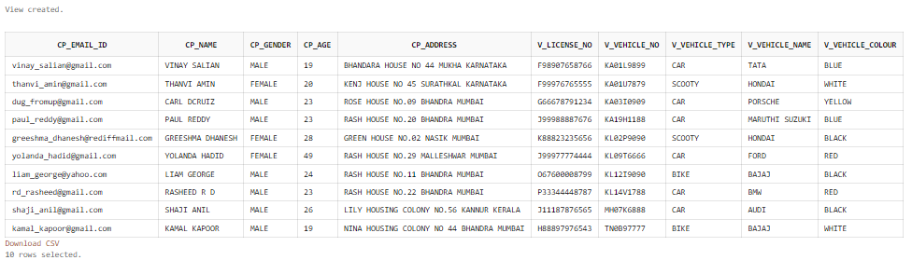

* V_DOCTOR_PATIENT

**CREATE A VIEW FOR THE DOCTORS TO VIEW THE MEDICAL DETAILS OF THE USERS.**

CREATE OR REPLACE VIEW V_DOCTOR_PATIENT AS SELECT CP_DETAILS.CP_EMAIL_ID, CP_DETAILS.CP_NAME, CP_DETAILS.CP_GENDER, CP_DETAILS.CP_AGE,

CP_DETAILS.CP_ADDRESS, CP_DETAILS.MED_HEIGHT, CP_DETAILS.MED_WEIGHT, CP_DETAILS.MED_BLOOD_GROUP, CP_PHONE.CP_PHONE_NO,

CP_HEALTH_ISSUES.MED_HEALTH_ISSUES, CP_ALLERGIES.MED_ALLERGIES, CP_EMERGENCY_NO.MED_EMERGENCY_NO

FROM CP_DETAILS,CP_PHONE,CP_HEALTH_ISSUES,CP_ALLERGIES,CP_EMERGENCY_NO WHERE CP_DETAILS.CP_EMAIL_ID = CP_PHONE.CP_EMAIL_ID AND CP_DETAILS.CP_EMAIL_ID = CP_ALLERGIES.MED_EMAIL_ID

AND CP_DETAILS.CP_EMAIL_ID = CP_HEALTH_ISSUES.MED_EMAIL_ID AND CP_DETAILS.CP_EMAIL_ID = CP_EMERGENCY_NO.MED_EMAIL_ID;

SELECT * FROM V_DOCTOR_PATIENT;



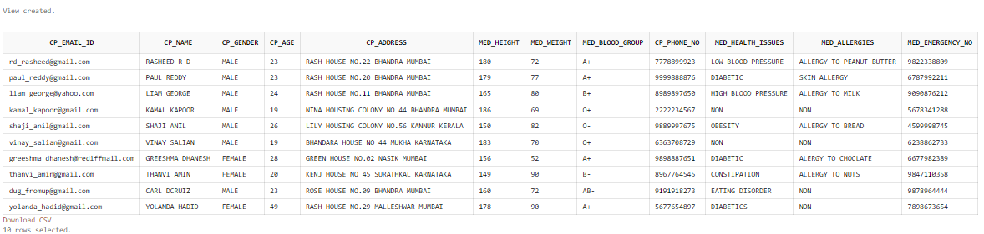

* V_PATIENT_STATUS

**CREATE A VIEW FOR THE DOCTORS TO VIEW AND UPDATE THE PROCEDURE DONE AND STATUS OF A PATIENT.**

CREATE OR REPLACE VIEW V_PATIENT_STATUS AS SELECT DC_PATIENT_DETAIL.DC_PATIENT_ID, DC_PATIENT_DETAIL.DC_PATIENT_DETAIL, DC_PROCEDURE.DC_PROCEDURE_DONE, DC_DETAILS.DC_PATIENT_STATUS

FROM DC_DETAILS, DC_PATIENT_DETAIL, DC_PROCEDURE WHERE DC_DETAILS.ID = DC_PATIENT_DETAIL.DC_PATIENT_ID AND DC_DETAILS.ID = DC_PROCEDURE.DC_PATIENT_ID ;

SELECT * FROM V_PATIENT_STATUS;



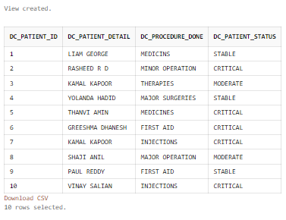

* **INDEX:**

**INDEXING IS DONE FOR CP_DETAILS, MINOR_DETAILS, VEHICLE_DETAILS, DC_DETAILS, P_DETAILS BECAUSE THESE TABLES ARE LARGER IN SIZE, SO THE WHOLE TABLE CAN'T BE STORED IN THE MAIN MEMORY. SO USING INDEX THE RETIRIVAL IS DONE EASILY FROM THESE TABLES. ALSO THESE TABLES ARE NOT MANIPULATED OFTEN SO INDEXING CAN BE DONE ON THEM.**

* I_CP_DETAILS

CREATE UNIQUE INDEX I_CP_DETAILS ON CP_DETAILS (CP_EMAIL_ID);

SELECT INDEX_NAME, INDEX_TYPE, TABLE_NAME, UNIQUENESS, VISIBILITY FROM ALL_INDEXES WHERE TABLE_NAME='CP_DETAILS';



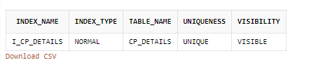

* I_MIN_DETAILS

CREATE UNIQUE INDEX I_MIN_DETAILS ON MINOR_DETAILS(ID);

SELECT INDEX_NAME, INDEX_TYPE, TABLE_NAME, UNIQUENESS, VISIBILITY FROM ALL_INDEXES WHERE TABLE_NAME='MINOR_DETAILS';



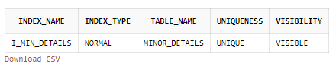

* I_VEHILCE

CREATE INDEX I_VEHICLE ON VEHICLE_DETAILS(V_VEHICLE_NO,V_LICENSE_NO);

SELECT INDEX_NAME, INDEX_TYPE, TABLE_NAME, UNIQUENESS, VISIBILITY FROM ALL_INDEXES WHERE TABLE_NAME='VEHICLE_DETAILS';



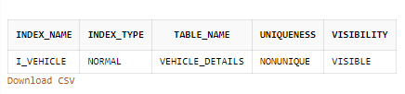

* I_DC_DETAILS

CREATE UNIQUE INDEX I_DC_DETAILS ON DC_DETAILS(DC_PATIENT_ID);

SELECT INDEX_NAME, INDEX_TYPE, TABLE_NAME, UNIQUENESS, VISIBILITY FROM ALL_INDEXES WHERE TABLE_NAME='DC_DETAILS';



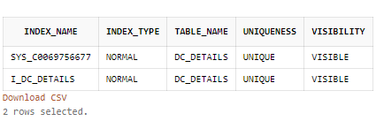

* I_P_DETAILS

CREATE UNIQUE INDEX I_P_DETAILS ON P_DETAILS(P_EMAIL_ID);

SELECT INDEX_NAME, INDEX_TYPE, TABLE_NAME, UNIQUENESS, VISIBILITY FROM ALL_INDEXES WHERE TABLE_NAME='P_DETAILS';



